Statistics on sensory data
Most important parts of the book

[Science2010]
Most useful parts of Chapters in the book
In most of the book we will consider sensory panel data and also consumer rating data as continuous interval scale data. This means that the differences between two different values will be considered meaningful, not only the ordering of the data. If the data are collected as rank data or as choice/preference data, it is necessary to use methods developed particularly for this purpose.
Chapter 2 deals with
sensory panel methodologies:
• Descriptive sensory analysis (or so-called sensory profiling) is probably the most important method in sensory analysis and also the one that will be given the most attention here. This is a methodology which is used for describing products and differences between products by the use of trained sensory assessors (…). In some cases, the assessors are allowed to use their own vocabulary (free choice profiling, FCP, see e.g. Arnold and Williams, 1987), but this type of analysis will not be given attention here. In this book sensory analysis data will be treated in several of the chapters (3,5,9).
•Discrimination tests (difference tests) is used for testing whether the assessors, either consumers or sensory panellists, are able to detect small differences between products tested.
consumer tests:
• Hedonic (or affective)tests
In this book, main emphasis will be given to experimental consumer studies with a hedonic response. Experimental consumer tests may be conducted in central locations or labs, in homes or via internet. For the purpose of this book, which is mainly about statistical methods, a clear distinction between these techniques will not be made, because the data structures and statistical analysis techniques are usually the same for all. For a deeper discussion of all these aspects we refer to Lawless and Heymann (1999) and references therein.
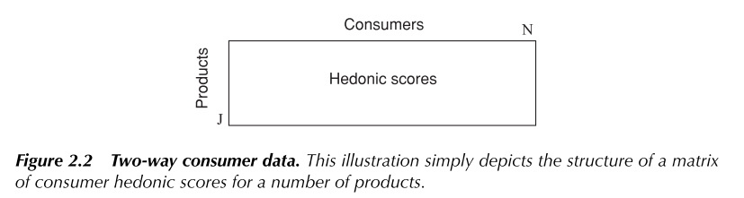
• Self-explicated tests
tests in which the consumers are asked which of a series of attributes they put most emphasis on when they make choices. They may also be asked to rank the importance of the attributes. These cannot be used for assessing interactions between the attributes.
• Rating based studies
main attention here: The consumers will typically, as for sensory analysis, give a score between a lower and an upper value for each of the products regardless of which question they are asked to respond to.
• Ranking tests (Chapter 7,17)
In this type of test all possibilities (samples) are presented simultaneously to the consumers and they are asked to rank them according to for instance liking. Since the data are ordinal and the sum of all assessments for each assessor sum to a constant, this limits the number of possible analysis methods considerably.
• Choice tests (Chapter 8)
• Auctions and Monitoring of behavior
• Additional Consumer Attributes and Characteristics
Chapter 3 | Chapter 4
Techniques for detecting and visualizing individual differences for quality control purposes. These methods can also be important for obtaining improved knowledge about sensory analysis as a measurement technique and about important differences in assessors’ capabilities as panel members  The working strategy starts with methods focussing on the overall aspects of the data (like ANOVA) and concludes with a more detailed analysis of specific problems detected (correlation plot, profile plots ecc…) | Remedy aspects  - For example, after ANOVA results, assessors use the scale differently. They have a different average and they also sometimes score the differences between the products differently
Chapter 3 focuses on quality control of trained sensory panels to improve the panel and for better handling of the actual data. (The chapter is strongly related to the remedies and panel improvement methods in Chapter 4 and is based on theory that can be found in Chapters 11, 13, 14 and 17.)
This chapter is about quality control of sensory profile data. For such data to be meaningful, it is important that the assessors are calibrated and that they use the sensory attributes the same way. Regardless of how well the calibration is done, there will always be individual differences between the assessors in their way of assessing the samples. The focus of this chapter will be on detecting the different use of the intensity scale or differences in ability to discriminate between the samples. If individual differences in performance are neglected, the final results may suffer from bias and imprecise conclusions, but usually we have to live with the data at hand and seek to make the best out of them even when the individual differences are large. In a worst case scenario, it might be necessary to discard certain assessors or attributes from the data set in order to eliminate large unwanted variability. A better solution could be to pre-process the data by one of the methods discussed in Chapter 4 and possibly weigh down negative effects before further analysis
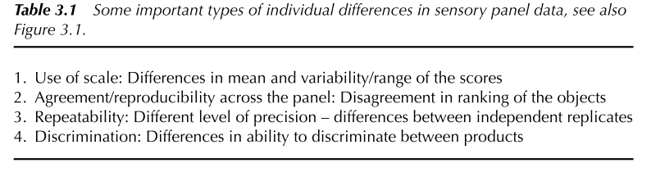
1. How assessors use intensity scale (no direct link to the quality of assessor)
2. Agreement or confusion among assessors regarding definition of an attribute
3. error variance or the assessors’ ability to reproduce or repeat a similar intensity value for the same stimulus
4. more specific in the sense that here the only focus is on detecting differences between products
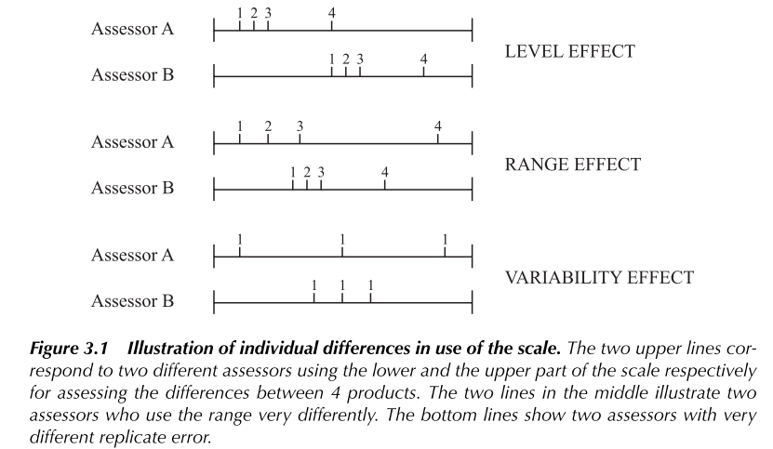
(The sample dataset used here: J=7 apples, K=20 sensory attributes, I=9 assessors with two randomized replicates in the data set)
GUARDA FLOW CHART PAG.14, here STEPS
1• Start by discussing simple visual inspection of the raw data to remove outliers before starting analysis
A number of simple tools are available for this purpose:
- Use of average values accompanied by standard deviations (Chapter 5 and 11) (lo posso fare ad esempio per ogni attributo presentando una colonna (mean) per ogni assessor e la standard deviation superimposed)
- Non mi accorgo degli outlier quindi utilizzo box plot e istogrammi (depicts the scores for one assessor and a certain attributes), ma used for cases where some assessors appear to be very different from the rest (as I*K histograms are needed)
- Use of line plots: show the product profiles averaged across assessors and replicates with the scores of individual assessors superimposed in the same plot
2• As a next step one will normally seek an overview of the panel performance using a mixed model ANOVA with assessors and products as the effects (Chapter 13) for all the attributes. Two-way mixed model ANOVA (which can be conducted also to deal with unbalanced data) here can be used to eliminate non-important attributes to eventually remove them from final considerations. Results of the ANOVA for can be displayed in three plots, one for the assessor effects, one for the product effects and one for assessor∗product interaction. Each plot contains a number of bars representing the F-values for the tests (see Chapter 13). In addition, each bar may be coloured according to a set of significance levels:
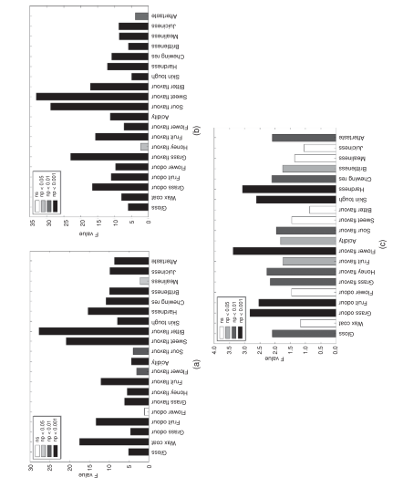
http://www2.compute.dtu.dk/courses/02930/SummerschoolMaterialWeb/Material/Tuesday/From_simple_to_3way_ANOVAHA.pdf
As always when using ANOVA in sensory analysis, one should keep an eye on the distribution of the residuals. One needs to check whether their distribution is reasonably normal and whether it contains any outliers. These and other aspects related to model assumptions are discussed in Chapters 13 and 15. In the example presented in Chapter 15 (Figure 15.7), the residuals have a distribution which is close to normal.
- It may, however, be useful to take a quick look at one of the individual plots below, for instance the p∗MSE plot (p-values are plotted along the vertical axis vs. MSE values along the horizontal axis), even for the nonsignificant attributes since one or a few very ‘unreliable’ assessors may possibly be the reason for the lack of significance
(See also PanelCheck_August2015HA)
3• Next step that follows the elimination of unimportant variables is multivariate analysis of all the remaining assessors and attributes simultaneously using the Tucker-1 method (Chapters 14 and 17) in order to obtain a simultaneous overview of the relation between attributes.
This is an overall Assessment of Assessor Differences Using All Variables Simultaneously!
Here Tucker-1 (Consensus PCA (CPCA)), that is basically, PCA on the horizontally unfolded matrix obtained from the three-way sensory data structure
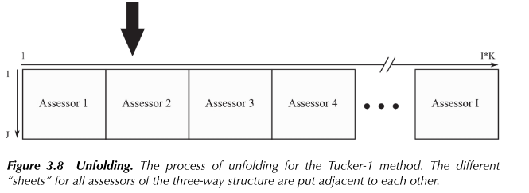
(new unfolded matrix then consists of J rows, where each row represents the average across replicates, and I∗K columns)
ASSUMPTION: it is possible to describe most of the information adequately by a relatively small number of common principal components or latent variables (2 or 3)
Scores are common for all assessors, only the loadings are different. Hence, one can present the results of this analysis in two types of plots:
- common scores plot (Chapter 14); how the samples relate to each other (J total plots)
- correlation loadings plot; individual loadings for all assessor-variable combinations (plots with I*K values)
For assessor and attribute combinations with low signal to noise ratio or for situations where the assessors interpret the attribute differently, the corresponding correlation loadings will generally be located closer to the centre (origin) than others, making it possible to identify variables with weak relation to the general underlying data structure. For a well-trained and calibrated panel, the correlation loadings of the attribute under investigation should be close to the outer ellipse with all panellists clustered closely together.
Dahl et al. (2008) proposed to generate K identical plots highlighting correlation loadings of one single attribute at a time using a label to indicate the assessors. This series of plots represents a practical way of identifying assessor-attribute combinations which are different from the others in some way.
INTERPRETATION: for a single attribute, an assessor has a high explained variance in the data for this attribute if they fall as far as possible (so near the outer circle)
The Tucker-1 analysis is usually done without standardising the variables (Chapter 14).
In general, the Tucker-1 plot is most useful for a higher number of samples (for instance for 7 and higher).
- Manhattan plot (Chapter 14); another important option for providing information about differences between assessors
For a single attribute, a plot shows the explained variance for all the assessors. The method is most useful when the explained variances for the different attributes are presented in separate plots. Manhattan plots can be used to:
- visualize the explained variances for each assessor-attribute combination for Tucker-1
- individual PCA analyses for the different attributes (quello che fa nel libro)
In questo secondo caso, the horizontal axis represents the assessors and the vertical axis represents the principal components from the individual PCAs. The cumulative explained variances for each principal component are visualised with colours varying from black to white.
The Manhattan plots provide no information on how the assessors rank the samples. This means that assessors may have explained variances that look very similar, but their sample ranking can be completely different. Other plots need to be consulted to obtain this information
→ Methods for Detecting (and correct) Differences in Use of the Scale (see point 1 in the Table 3.1)..
In general, different use of the scale has two important aspects;
- the level effect which corresponds to the positioning of the mean score along the intensity scale
- the range effect which corresponds to the variability of the scores
Solutions:
1. Computing Means and Standard Deviations for Each Assessor and Attribute Combination (across all tested samples and their replicates); one plot for each attribute, with all assessors on it
2. Minimising Differences between Assessor Scores for the Same Product and Attribute [Næs (1990)] (The algorithm for finding the solution is simple and based only on simple eigenvector calculations; a criterion is chosen for each attribute $k$…)
3. The Brockhoff Assessor Model; the model (for each attribute $k$) takes into account different use of scale and also different individual variances. The model can be presented in such a way that it also contains the main effects for products, but for the purpose of assessor evaluation, this aspect has no influence.
Also this method can be used to reveal different/opposite ranking of the samples (see point 2 in Table 3.1)
→ Comparing the Assessors’ Ability to Detect Differences between the Products; (see points 3 and 4 in Table 3.1)
TILL THE END OF POINT 2. we are only considering attributes that are significant

Has the design of the sensory panel study may sometimes have an effect on some of the tools discussed here) (Chapter 5 and 13)

[Science2010] “IMPROVING SENSORY PANEL DATA”(Data pretreatment)
These aspects Chapter 4 in connection with how to improve sensory panel data (improving sensory profile data) → Unreliable assessors, in the sense that they provide very noisy data or are very different from the rest can reduce the validity of sensory panel averages.
What should we do with data from assessors that are less reliable than the others?
How we could pre-process data before averaging?
pre-processing of data before three-way analysis.
$$↓$$like to use the data at hand, for instance for computing panel averages, even if some of the assessors are different from or less reliable than the rest.
In this chapter main attention of attribute-wise pre-processing methods before ANOVA or averaging over assessors
If differences in reliability are detected, it may be natural to weigh down the most unreliable assessors when computing the panel average.
Differences in use of the scale are not directly related to the reliability of the assessors, but it may be important to correct for them before averaging in order to make the data comparable across assessors.
FIRST
obtain a scaled dataset(CORRECTING FOR THE USE OF THE SCALE)
The structure of the data considered here is the same as used in Chapter 3 and depicted in Figure 2.1 (J samples, I assessors and K attributes). In some cases also external data of the same samples (J samples) will be used.
It may therefore sometimes be advantageous to pre-process the data before further analysis, being it ANOVA or multivariate analyses based on panel averages (see Chapter 6) (Note that when applying ANOVA methods, correction for position is done automatically if an assessor effect is incorporated in the model).
$→$ IN OUR ANOVA MODEL THE ASSESSOR IS THE ONLY EFFECT
Different ways to obtain a scaled dataset:
The simplest method for reducing differences in range is to divide scores for each assessor and attribute combination by the corresponding standard deviation, i.e. standard deviation obtained across samples and replicates. This means that for each combination of attribute (k) and assessor (i) one computes the quantity:
$$y_{ijkr}\left(new\right)=\frac{y_{ijkr}\left(new\right)}{s\left(y_{ik}\right)}$$
Where the standard deviation $s\left(y_{ik}\right)$ is taken over all samples and replicates. Usually, the data will be centred for each individual prior to the transform.
- Slightly more complex method: scale the different assessors with the purpose of making them as similar as possible in a least squares (LS) sense.
…………In chapter 3 (3.5.2 “Minimising Differences between Assessor Scores for the Same Product and Attribute”) (…) another method based on a mathematical technique: the average scores (over replicates) $y_{ijk}$ for assessor I, product j and attribute k are all multiplied by a costant $c_{ik}$ independent on the samples $j$ (CHE PER NOI SONO O TRACCIA O SPEAKER, GUARDA IN VERTICALE) which are optimized such that the scores for all products and attributes become as similar as possible. The optimization is done for each attribute (k) separately using the criterion:
$$Criterion\left(k\right)=\sum_{j=1}^{J}{\sum_{i<i^{'}}{{\left(c_{ik}y_{ijk}-c_{i^{'}k}y_{i^{'}jk}\right)}^{2}}} \left(3.2\right)$$
In order to obtain a non-trivial solution, a restriction is put on the c-values (see Naes(1990) for details). The algorithm for finding the solution is simple and based only on simple eigenvector calculations. The advantageof this method as opposed to the method above is that is also offers diagnostic procedures.
For example, one can look at the individual contributions to the sum to identify assessors that do not fit the rest. Negative constants $c_{ik}$ are indications of attribute-assessor combinations for which the order of samples is reversed, thus indicating a confusion or very large random noise.
……… HERE the criterion to minimise for this procedure is the same as used in Equation (3.2) After estimation of the correction constants, new data are obtained by multiplying the original score values by the estimated values. Figure 4.1 shows the scaling constants for a concrete example with 6 attributes and 10 assessors. The scaling constants minus 1 are presented in order to highlight the differences between those values which are higher and those that are lower than 1. A scaling constant equalling 1 corresponds to no change. The values are sorted according to assessor.
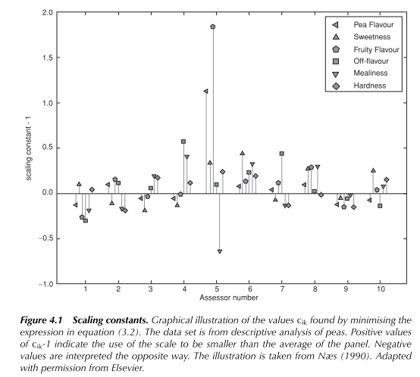
- Martens (2008) has proposed to use a method inspired by the MSC transform (Geladi et al., 1985) for spectroscopic data for the purpose of reducing scaling differences
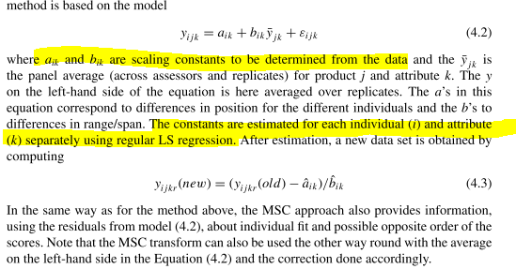
- Fitting the Brockhoff model to the data and then computing the differences between the raw data and the predicted values from the model (the residuals) thus obtaining corrected data to be used for further analysis
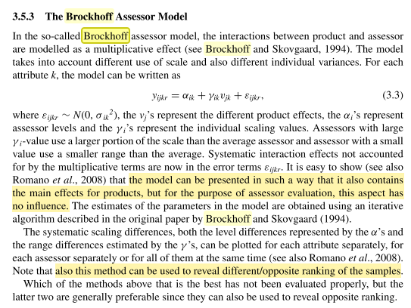
THEN
(When computing a weighted average, it will here always be assumed that the data have been scaled by one of the methods above prior to averaging)
computing improved panel averages:
Unreliable assessors, in the sense that they provide very noisy data or are very different from the rest, can reduce the validity of sensory panel averages. In such cases it may be tempting to reduce their influence by giving them less weight when computing the panel average (QUINDI DOPO AVER GIA’ RIMOSSO L’OUTLIER PER NOI)
THE GENERAL WEIGHTED AVERAGE FORMULA for the weighted average profile for sample j can then be written as:
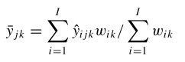 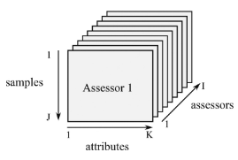
Here $\hat{y}$ represents raw data (EVENTUALLY here averaged over replicates) or raw data that have been smoothed before averaging as will be discussed below.
Note that setting one of the assessor weights equal to 0 corresponds to eliminating that assessor from the new weighted average. Note also the resemblance between this and weighted least squares fitting based on estimated weights (iteratively reweighted regression (Weisberg, 1985).
SO, we can compute improved panel averages by computing a weighted average, where the weights $w_{ik}$ are computed according to one of the criteria to be discussed below:
For computing the weight, we therefore recommend the use either relations to the average profile or differences between replicate measurements. (NOI NON ABBIAMO REPLICATE MEASUREMENTS)
A POSSIBLE WEIGHT COULD BE:
- Correlation coefficient between an average assessor and the average profile (possibly with the actual assessor eliminated)
Assessors with a weak relation to the average will thus be weighted down.
Assume the average profile to be:
$$X=\frac{1}{k} \sum_{k}{X_{k}}$$
If the matrices $X_{k}$ are the $K$ matrices of ratings for each assessor /
/
Another possibility is to use 1 divided by a function of the standard deviation of the random noise. A standard deviation of the noise can be obtained by pooling standard deviations of the replicated measurements for each sample/assessor/attribute combination or by using residuals from a Tucker-1 modelling (see Chapter 14) of the raw data. The Tucker-1 method has the advantage that one does not use explicitly the information about which observations that are replicates.
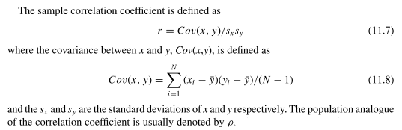
- STATIS (see [naes1996] on CHAPTER 17)
The method automatically weighs the contributions of the different matrices by using the so-called RV coefficients. This is an index measuring the degree of correspondence between data matrices and in this way can be used to put less emphasis on the individuals which are most different from the rest.
STATIS ends up with a consensus matrix representing a type of average for all the assessors.
This matrix can be used like regular average data matrices as described in for instance Chapter 6
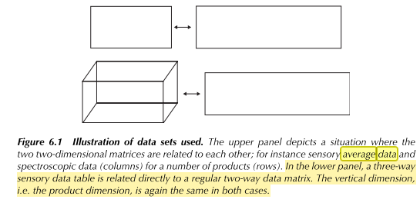
$↓$
[naes1996]
The STATIS method is another method for individual profile data which looks for similarities and differences. This method is treated in Chapter 9. The method is based on maximizing correlations among the profiles and provides plots/maps of a similar type as most other methods treated in the book.
(CHAPTER 9) “Defining and validating assessor compromises about product distances and attribute correlations”
A noi in questo contesto ci interessa la risposta alla domanda:
How can the similarity between two individual sample spaces be measured?
The basis of this framework is the RV coefficient, more specifically, STATIS is a non-iterative 3-way multivariate analysis, based on the RV coefficient, which defines a compromise among assessors about the sample differences.
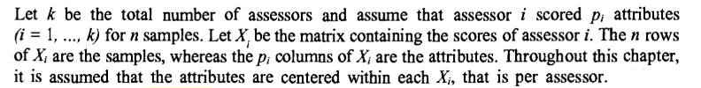
The question of choosing the attribute weight system, also called metrics, is more important. Metrics is a way of computing distances between samples. Generally speaking, it is a positive symmetric matrix Q of size p (the number of attributes). As Q can be different among the assessors, sometimes it will be called $Q_{i}$.
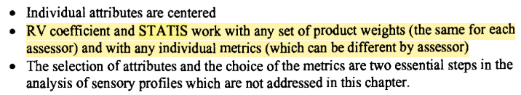
the association matrix $W_{i}=X_{i}X_{i}^{'}$ contains the full information about the multidimensional differences among samples found by subject i. The association matrices are the basis of the subject comparisons in STATIS, which can therefore be done even if the assessors did not score the same attributes.
(…)
2.4. Comparing two individual sample spaces by means of the RV coefficient
The quantity: 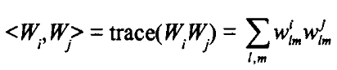$(1)$
is the natural scalar product between two matrices, where $w_{lm}^{i}$ is the (l,m)-th element of matrix $W_{i}$.
The quantity: 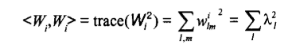(2)
In this context, the RV coefficient is 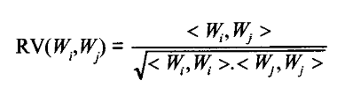 (3)
(generalised correlation coefficient between $W_{i}$ and $W_{j}$ matrices)
The closer the RV is to 1, the more similar assessors i and j are in terms of their standardized product distances
(………) In comparing two assessors, while (1) depends on the use of the scale, the generalized correlation in (3) is better. (………) Reader must understand that this matrix standardization is different from the classical attribute standardization, which is done by a PCA of correlation matrix. Contrarily to this normalized PCA, RV takes into account the differences between attribute variances for a given assessor. (………) RV coefficient is a measure of the similarity between two individual sample spaces. RV is the classical correlation coefficient between the two square matrices of sample scalar products of size (n,n) having been previously arranged within two vectors of size $n^{2}$.
2.5. Testing significance of a RV coefficient by an exact permutation test of the products
$→$is the agreement between the two assessors is better than what can be obtained by chance??
because the magnitude of a RV coefficient depends on both the number of observations and the number of variables in the two data sets, there is a need for a statistical test of RV significance. An exact non parametric permutation test is available, it makes it possible to declare whether two assessors agree more than what can be just obtained by chance (SALTA QUESTA PARTE)
2.6 Defining and interpreting a compromise sample space among the assessors by means of the STATIS method
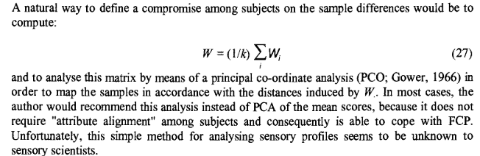
The STATIS compromise W differs from this natural compromise W, because the latter is a classical mean, whereas the STATIS compromise is a weighted mean of the $W_{i}$:
$$W=\sum_{i}{a_{i}W_{i}}$$
Where ${\left(a_{i}\right)}_{i=1,…,k}$ is the first eigenvector of the matrix of size (k,k) containing the RV coefficients between assessors.
(HO
The components of this vector are positive and normalized to get a sum equal to one. This vector represents the "principal agreement among assessors". Thus, the greater the $a_{i}$, the more assessor i agrees with the panel on the sample differences. The strategy of STATIS is therefore to put weights on subjects proportionally to their agreement with the panel. Therefore, the weight of an outlier should be close to 0.
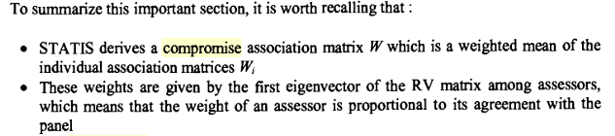
(…….)
NO TESTING OF SIGNIFICANCE

pre-processing of data for three way analysis:
Trying to improve three-way analysis by the use of pre-processing, there are two main aspects to take into account:
1. Correct for scale differences (SAME AS ABOVE)
2. Take the reliability of the assessors into account
The general structure of many three-way methods is the minimisation of the criterion (incorporating weights into account):
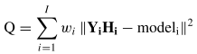
(See page 45 and Chapter 17).
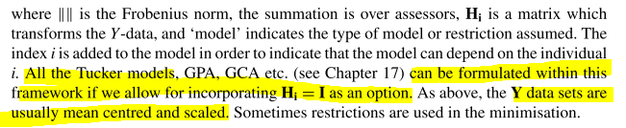
SIMPLEST WAY TO INCORPORATE WEIGHTS IN THIS CRITERION
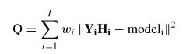
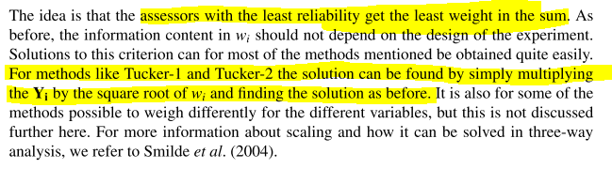
[naes1996] “Data pretreatment in TFWA models”
(5.2 Weighting)(Pag.320) In addition to standardizing the data by removing variation due to differences in attribute and assessor means, it is often sensible to standardize variation. This can be done by dividing each attribute by its standard deviation, and as with centering there are two options.
The standard deviation can be computed over the whole sample or for each assessor separately. As above, the two options have quite different effects on the results.
1. The first option considers each assessor to be using the same scale, so that if he/she uses a smaller part of the scale than the others, he will still after weighting have less influence on the TWFA solution than the rest. In other words, this type of weighting will only have an effect on the relative importance of the different attributes, with no reference to the difference in scale among the different assessors.
2. The second option on the other hand also has an effect on the relative importance of the different assessors by weighting them all equally. In this way, we can say that each assessor is transformed to the same scale.
The choice between the two weightings depends on what is believed about the assessors' performance: if it is thought that an assessor will use a large part of the scale if he/she is confident about there being a large difference between the samples, and that a small difference means he/she perceived very little difference, then the weighting should be across all assessors. If on the other hand it is believed that each assessor perceives differences in the same way, and simply chooses to use the scale differently, then the standardization should be done within assessors.
This gives rise to another possible scaling, in which each assessor is given weight proportional to his ability to detect differences among the objects. One way to do this, if there is replication within assessors, is to 3. give each assessor a weight proportional to his average F-value for the different attributes. This could for instance be combined with centering the different attn'butes within each assessor. Another poss~ility is to give each assessor and attn~oute combination a weight proportional to its particular F-value.

Next chapter have the same theoretical basis…
Chapter 5 | Chapter 6
Analysis of variance of sensory data based on factorial design  From Chapter 3, the first step after simple raw data inspection is typically to perform a simple mixed model ANOVA with assessors and products as the effects ($→$Chapter 13). If replicates are random replicates with no systematic structure among them, a two-way mixed model with interaction is the most appropriate ($→$Chapter 5).  If, however, the replicate structure is systematic, it may be advantageous to use a three-way model with replicate as the third effect as discussed in Chapter 5. In such a case, all two-way interactions should be incorporated and the replicate effect treated as random. Mixed model ANOVA can also be conducted for unbalanced data, i.e. with different number of replicates for each assessor and product combination.  Dal capitol 4 dice: “it can be argued that if the scaling differences play an important part of the interactions, the standard ANOVA assumptions are more realistic after correction than before correction. This is discussed further in Chapter 5, Section 5.2.2 where also an alternative modelling approach for handling scaling differences in ANOVA is presented” | Focus on regression methods where the external data are considered to be continuous and in some cases also highly collinear.

The design of the sensory panel study may sometimes have an effect on some of the tools
discussed in Chapter 3….
Chapter 5 (and 13) for a discussing of various ways of conducting sensory analysis and how this may lead to different replicate structure in the data

NOTE! Il fatto che io usi lo stesso metodo statistico per fare consensus o individual profile (o ogni ccosa che è descritta in questo libro anche nei capitoli prima) non centra…
CI SONO DELLE METODOLOGIE STATISTICHE / ALGORITMI DI FITTING_REGRESSIONE / OTTIMIZZAZIONE CHE SONO QUELLI (in [Science2010] vengono descritti da capitoli apposta) POI A SECONDA DI PER COSA LI USO VIENE DEFINITO DAL MIO OBIETTIVO
Poi ad esempio in ognuno di essi bisogna vedere che tipo di dataset ho. Il discorso sull'individual profile è a prescindere se voglio legare una tabella di dati three-way con una two-way, una two way con una two-way, che tipo di informazione mi serve.

|
|
|
|
| Il concetto è che l'utilizzo di external data ad esempio potrebbe essere fatto anche per la validazione o
| altre cose di un individual sensory profile. Esempio: TFWA methods can be used to investigate
| similarities and differences between objects, assessors and attributes at the same time (in questo caso mi
| riferisco a un three-way method ma con uno scopo diverso da quello predittivo!!)
_______________

(!!!!)Il contesto generale per legare three-way models to other data [naes1996]
(da pagina 321[naes1996] → (RELATING THREE-WAY MODELS TO OTHER DATA)
Sometimes it is of interest to predict sensory profile data from external measurements.
WHY WE MAY BE WANT THIS?
• understanding of the sensory data and the individual differences
If the aim is improved understanding of Z it may be of interest to see the relationship between the external measurements and each individual assessor.
• replace the sensory measurements by some fast and reliable instrumental measurement NOSTRO CASO!
If the aim is replacement of sensory data by instrumental measurement, prediction of the average score is often more relevant.
FOR BOTH SITUATIONS, there is a matrix Y of external information to be related to the individual profiles Z:
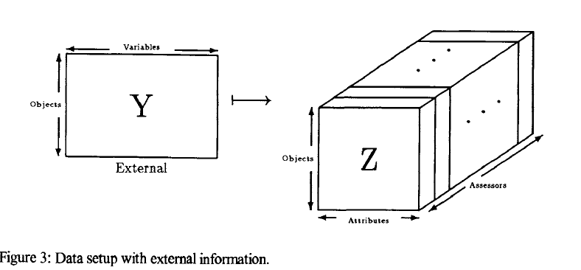
This can be done by standard multivariate regression techniques such as principal component regression and partial least squares regression.
•The simplest way to use TWFA models to link sensory data with external data is to compute score matrix T and relate it to the external data Y by some regression technique, i.e (sto assumendo che tra le due ci sia un modello di regressione):
$$T=BY+E$$
The matrix T is estimated first, then related to Y to get a relationship between Z and Y. This approach can be used for both prediction and understanding.
• An alternative which is more goal-oriented and also sometimes easier to compute is to apply the restriction T = BY directly in the factor model. In other words, the restricted matrix T=B Y is substituted into the general model $X_{i}=TW_{i}P^{'}$ and the parameters W, B and P are optimized by for instance the least squares criterion $→$ minimize the error:
$${\sum_{i=1}^{m}{\left\|X_{i}-TW_{i}P^{'}\right\|}}^{2}={\sum_{i=1}^{m}{\left\|X_{i}-\left(BY+E\right)W_{i}P^{'}\right\|}}^{2}$$questo stesso modello di equazione lineare
è quello che si applica sia al Tucker-2 e al PARAFRAC
nel contesto del fitting
In practice the Y variables may often be highly collinear. In order to obtain stable solutions, they can be replaced by the principal components corresponding to the most interesting information
(…)

[Science2010] “RELATING SENSORY DATA TO OTHER MEASUREMENTS (IN GENERAL!)”
$\boxed{Chapter 6 }$ is devoted to “relating Sensory data to other measurements”
(finding relations between sensory data and other types of measurements.). Important examples of situations where relations to other data are important, is (from the book, the similar one we are interested in):
- The ‘replacement’ of sensory panel data by quick chemical or spectroscopic measurements. Sensory analysis can sometimes be rather time consuming and it may be difficult to have a stable, reliable and well-calibrated sensory panel available at all times in a production situation. …… stuff like rapid profile techniques …… are known to be very reliable and informative in a production environment and can be used also for nondestructive measurements online. If one is able to establish a reliable prediction equation for the sensory data based on the ……….. the prediction equation may be applied in industrial quality control with substantial time and cost reduction (Martens and Martens, 1986; Kjølstad et al., 1990).
BUT WHAT ABOUT THIS IN AUDIO FOR EVALUATION OF SPEAKERS?!?!?!?!?
The data sets used in this chapter are a sensory data set as depicted in Figure 2.1 (three-way framework) and a data set containing other types of measurements for the same samples:
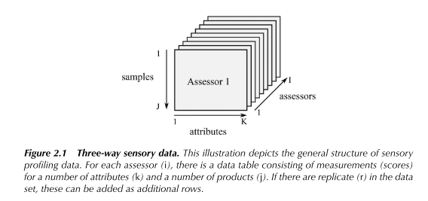

The analysis methods described in this chapter require that the sample dimension (vertical dimension) must be the same for both data sets.
In most of the cases treated here, the sensory data will be averaged across assessors such that finding the relation between the sensory and external variables can be done by regular multivariate regression (Figure 6.1). * We
→ We will also discuss briefly a number of different ways of computing this type of averages. This aspect is, however, primarily discussed in $→$ Chapter 4 in connection with how to improve sensory panel data.
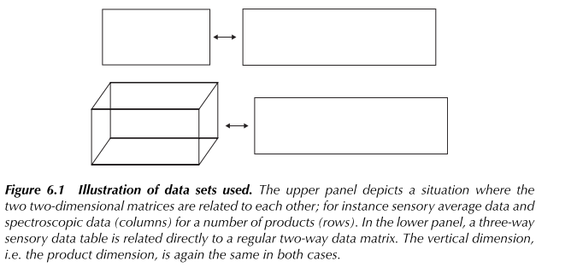
Focus here is on regression methods where the external data are considered to be continuous and in some cases also highly collinear. This requires a different focus and provides different tools for interpretation although the theoretical basis is the same.

|
|
________________________________
With consensus profiling, members of a trained sensory panel work in concert to agree magnitude ratings for each sensory attribute rather than providing independent ratings in duplicate or triplicate. A consensus sensory profile across all assessors. is a sensory profile where the results of all assessors are merged, and the main trends are identified [zach2019]. In conventional methods, e.g., QDA, this is statistically straightforward by use of multidimensional techniques such as principal component analysis (PCA).
→ estimating Relations between consensus Profiles and External Data
*Multivariate regression analysis (Chapter 15) is the appropriate methodology to apply for finding relations between complex data sets.
should the sensory data be predicted from the external data or should they be used as predictors?
sensory data as response data $\left(Y\right)$ and the design data (here in the example of the book chemical data) as predictor $(X)$.
When relating Y-data to X-data by the use of regression methods, there is always a need for a model and an estimation methodology. Here we will focus on
1 linear models $\left(Y=BX+E\right)$
2 estimation methods (as said in Chapter 15):
- principal component regression (PCR) $→$Chapter 15
- partial least squares (PLS) regression $→$Chapter 15
3 Tucker-1 method (another possibility more useful here)($→$Chapter 14 $→$Chapter 17) which belongs to a class of methods often referred to as multi-block methods.
This is a technique which tries to approximate both data sets (or several) by using data compression through a common scores model. This implies that Tucker-1 tries to find some common directions, components or latent variables that can be used to predict both X and Y in the best possible way. The method is described in some detail in Chapter 13. We refer to Westerhuis et al. (1998) and Kohler et al. (2008) for further discussion of this method
- Finding the best Consensus sensory profile to be used in $Y=BX+E$; the simplest way is use of regular averaging of all individual profiles for each sample separately (similar alternatives
$→$ Chapter 4)
- Linear regression methodology;
We have two possibilities:
• With multiple Y-variables, one simply regresses all of them onto the same PCA space obtained by the X-data. This method is useful since it solves the collinearity problem and provides several plotting and diagnostic possibilities.
• Another alternative is to use the PLS-2 regression method.
[naes1996] PCR AND PLS models (from pag.125 par.5) Principal component regression (PCR) is a tool which is used to predict one set of variables (Y- matrix) from another set of variables (X-matrix). The procedure is based on undertaking principal component analysis on the X-matrix, and then using the principal components as the predictor variables. Partial least squares regression (PLS) (Wold, 1982) is an extension of the PCR approach, and was developed by Wold as a method for econometric modelling.
(Comparison with NN approach here!)
The result of both methods is first of all a set of regression coefficients, the estimated $B$ matrix, in addition to scores plot and loadings plot and a number of diagnostic tools for detecting outliers.

The quality of the relation obtained should generally be validated by using either cross- validation or prediction testing on an independent data set. $→$Chapter 15
→For prediction purposes it is also possible to use the PLS for each of the Y-variables separately.

If there are multiple sets of external data……
- put them adjacent to each other and use regular PLS or PCR on the combined matrix
- multi-block PLS
- LS-PLS method

- Symmetric Multi-Block Methodology; the Tucker-1 method ((Consensus PCA (CPCA)).(
$→$Chapter 14
$→$Chapter 17)
is based on computing the PCA for the merged data matrix $Z = (X, Y)$ a horizontal concatenation of matrices X and Y. It is therefore often referred to as multi- block PCA. The fit of the model can here be determined by looking at the residuals from both blocks and comparing the variability with the total variance
MA IN GENERALE….
[naes1996] “Fitting the TWFA models”
Tucker 1
this model is based on unrestricted minimization over $T_{i}$ and $P$ of quantity ${\sum_{i=1}^{m}{\left\|X_{i}-T_{i}P^{'}\right\|}}^{2}, P^{'}P=I$
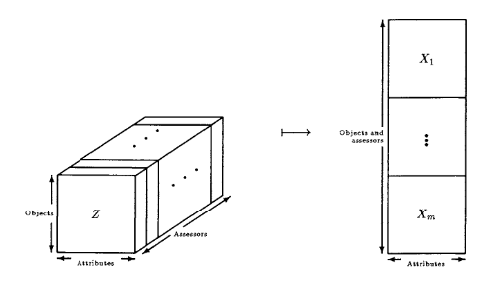(unfolding of three-way data matrix)
for the common loadings model, and minimization of an analogous expression for the other two models. If the three way matrix is unfolded to give an mn x p matrix, as in Figure 2, then it is easy to see that the minimization is achieved by a standard PCA or SVD of the unfolded matrix. Notice
Tucker 2
In this case the minimization is over $T$, $W_{i}$ and $P$ of the equation ${\sum_{i=1}^{m}{\left\|X_{i}-T_{i}P^{'}\right\|}}^{2}, P^{'}P=I$ (or one of the other two forms) where Tis a set of common scores, P the common loadings and $W_{i}$ are the individual difference matrices to be estimated.
PARAFAC-CANDECOMP
In this case the optimization criterion is the same as above, but now $W_{i}$s are diagonal matrices
Tucker 3

ESEMPI DA CAPITOLO 6 (Pag. 71/74)
$↓$
• Predicting Sensory Data by Chemical Spectroscopy = Predicting sensory properties by the use, for instance, of spectroscopy. One is primarily interested in the sensory properties, but they may be difficult to obtain as frequently as wanted. Therefore it is useful to investigate the possibility of predicting them by fast and reliable online or at-line spectroscopy.
(Example of PLS regression method)
• Understanding Sensory Profiles in Terms of Chemical Measurements = understanding more about which chemical components that were responsible for the detected sensory effects
(Example of PLS-2 regression with the sensory data as responses (Y) and the chemical data used as X.)
• Optimising Product Properties
•External Validation of Sensory Data = external validation is useful for judging the validity and quality of the data at hand.
(Example of PLS regression method with sensory data as Y and the external data as X and estimate the relation)

→ estimating Relations between individual Sensory Profiles and External Data?
Using sensory measurements as response data
In the context of using sensory measurements as Response data, if the sensory data are treated as $Y$, the most common way of modelling the data is by the use of some multi-block or multi-way component analysis of the sensory data + subsequent or simultaneous regression of the low-dimensional consensus representation of the sensory data onto the external data.
In more mathematical terminology, this is the same as modelling the sensory data by:
- PARAFAC
- GCA
Generalized Canonical Analysis or GCA is a multivariate data analysis technique that studies the relationship between sets of variables (…) [naes1996] In IN OUR CONTEXT: 'On which attributes of the tracks do the assessors agree (for each speaker)?'
(…)
The original form of generalized canonical analysis is a technique that studies what is common between sets of (numerical) variables. The technique must provide answers on questions like: 'Can we predict the quality of a product from instrumental measures of the same product?' or 'Do several assessors agree in their judgements of a product and on what attributes do they agree?' When considering to use GCA, several (two or more) sets of variables must be involved in the research question.
- One of the Tucker methods
(see Chapter 17, Tucker, 1964; Smilde et al., 2004)
(see [naes1996])
and then regressing the low-dimensional consensus representation (T) of the samples onto the external data (X).
One step in a single process can be done by the Tucker-2 method:
$$Y_{i}=XBW_{i}P^{T}$$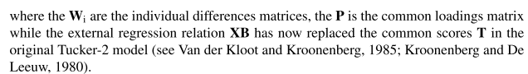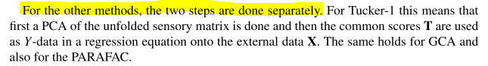
Mentre in una PCA normale…
(→ See Chapter 14)
La matrice $T$ (full set of principal component scores) è data dalla moltiplicazione dell’original data table e dalla matrice dei loadings $P$
ESEMPI DA CAPITOLO 6 (Pag. 74/75/76)
USING SENSORY MEASUREMENTS AS RESPONSE DATA
• Predicting the Average and Understanding Individual Differences
• External Validation for Determining the Best Data Compression
USING SENSORY MEASUREMENTS AS PREDICTOR DATA
when Y-data are used as predictor data (NO) is to use multi-block PLS regression (…)This is essentially a regular PLS regression of the unfolded data matrix followed with interpretation tools for investigating the individual differences. Another alternative is to use the LS-PLS (Jørgensen et al., 2004) approach mentioned above, but this approach is most useful for situations with only a small number of blocks (here assessors). A third possibility is the three-way PLS (Bro, 1996) which is essentially a combination of PARAFAC and regression. The common sample scores are used in the regression but they are determined in such a way as the relation to the external data is as good as possible
A parte l’analisi… LIKE ANOVA HERE…
(UTILIZZO QUESTE TECNICHE MA CI FACCIO ANALISI E BASTA NON RELAZIONANDOLE A EXTERNAL DATA)
[naes1996] Analysing individual profiles by three-way factor analysis (TWFA) without relating to other data (from pag. 303 UNA PARTE DELL’ultimo capitolo):
TWFA techniques are generalizations of principal components analysis (PCA) but while PCA works on two-dimensional matrices, TWFA techniques can be used to analyse three-dimensional matrices with three 'directions'or 'ways' of information (object, assessors, attributes).
They can be used to investigate similarities and differences between objects, assessors and attributes at the same time

Assuming we have $m$ assessors in the sensory panel measuring $p$ attnqgutes for $n$ objects. The data can then be collected in a three-way table Yijk, i = 1 ..... m,j = 1 ..... n, and k = 1 .... ,p. Replicates will here be denoted by l = 1 ..... q.
This type of data can always be described by an analysis of variance model:
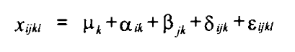(LIKE ANOVA!!!)
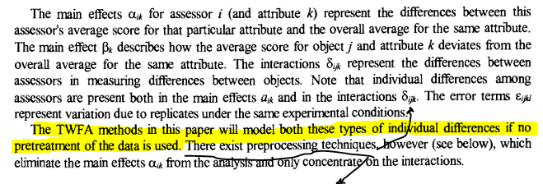
Why TWFA can be seen as a generalization of PCA? Three-way factor analysis techniques are generalizations of PCA developed for matrices with an extra way (or order):
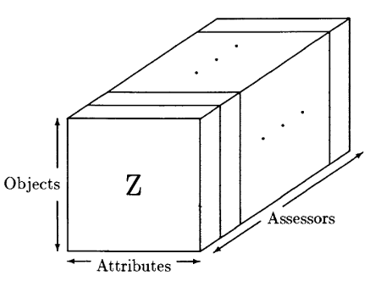
Each slice in the stack of matrices corresponds to one particular assessor and contains objects-by-attibutes information for that particular assessor. Of course, it is equally possible to slice the matrix in two other ways, with the slices then corresponding to either individual objects or attributes. It would be possible to do a separate PCA on each slice of the matrix, which would be to ignore any similarities between the assessors (or objects or attributes depending on how the matrix was sliced) or to take a mean over the slices and do a PCA on the resulting matrix, which would ignore any differences between them. TWFA is a form of PCA for the slices of the matrix which takes account of these similarities and differences
• Tucker1 modelling
• Tucker2 modelling
• Tucker3 modelling
• PARAFRAC

SULLA DEFINIZIONE MATEMATICA GENERALE DI QUESTI METODI CHE STO UTILIZZANDO

[Science2010] Chapt11 BASIS ON EVERYTHING STATISTICS!

[Science2010]Chapter13 ANOVA for sensory and consumer data (from [bech2006],[Science2010] Chapter 13) how to use PCA and ANOVA?
From Chapter 13 of [Science2010]
https://stats.stackexchange.com/questions/12398/how-to-interpret-f-and-p-value-in-anova
https://stats.stackexchange.com/questions/183559/what-question-does-anova-answer
GUARDA ALTRO FILE IN CUI SI E’ GIA’ STUDIATA ANOVA

[Science2010] $→$ $→$ $→$ $→$ $→$ Chapter15 MULTIPLE, PCR, PLS REGRESSION
(Basis for methodology on chap.4,6 (and 9))
Regression methods relate two sets of data to each other and are among the most useful and most used statistical methods. They are particularly useful in sensory science where one of the main focus points is to find relations between data sets.
- The classical method of least squares (LS) estimation will be discussed together with some of its shortcomings when the explanatory variables are collinear.
- Main focus will be on linear methods
FROM CHAPTER 11,
(11.7) Assume again that one measures two variables x and y and that there is a relationship between them. Assume further that x is simple to measure while y is more difficult or time consuming to measure, but also more interesting. One will then be interested in building a model between the two such that y can be predicted from measurement of x (Martens and Næs, 1989). The simplest model that can be used for the relationship between x and y is the linear model. This is a model assumption which may be reasonable or not, but often it is a useful approximation in real applications. The simple linear model can be written as:
$$y=β_{0}+β_{1}x+ε$$
The $ε$ represents the random error and usually one assumes that $ε$ ‘s are independent and that the variance is the same for all the observations, i.e. $Var\left(ε_{i}\right)=σ^{2}$ independently on $i$.
One can test hypotheses about the parameters!!
(…)
These methodologies will be extended in Chapters 15 to more realistic situations with several X- and Y-variables, which are directly relevant both in Chapter 6, 9 and at many other places in the book. (…)
NOW CHAPTER 15 $→$ Generalization for several X variables and Y variables
main attention to linear regression methods, but we will also show how these methods can easily be extended to handle nonlinear polynomials.
The linear regression situation with only one x and one y can easily be handled by calculating just variances and covariances of the variables as was shown in Chapter 11. The present situation with several x’s and also possibly several y’s is much more complex and in order to be able to describe this type of methodology properly one needs matrix algebra.
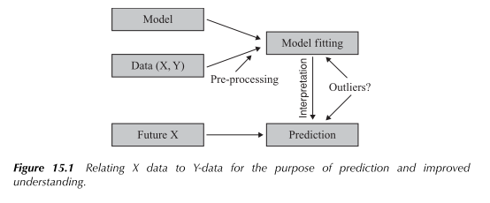
The (univariate)multiple linear regression model for a single observation (n) can be written in the following way:
$$y_{n}=β_{0}+\sum_{k=1}^{K}{x_{nk}β_{k}+ε_{n}}$$
Or, in compact matrix form:
$$y=Xβ+ε$$
RAPPORTANDOLO AL NOSTRO CASO è come se stessi dicendo che sto predittando un attributo soltanto che fa riferimento a tutte le $n$ osservazioni (ratings) per quell’attributo lì (sarà n=12 per noi)
NOTE THAT $β$ is a vector of predictor here
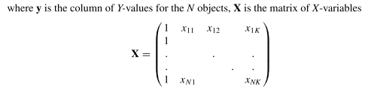
Note that if the X-variables are centred before analysis, the regression coefficients do not change, only the intercept. If the x’s are centred, the intercept is equal to the average of y.
If both x and y are centred, the need for an intercept vanishes completely. This fact will be used for PCR and PLS regression as discussed below in Sections 15.7 and 15.8.
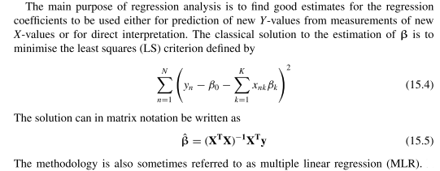
Quite often, also in sensory science, the number of variables may be large and the correlations among some of them may be very high. This can create stability problems of the regression coefficients (Gunst and Mason, 1977, 1979). This is often called the collinearity problem and will be given more attention below. In some cases, the number of variables can also be larger than the number of objects leading to mathematical rank problems when computing Equation (15.5).
Possible ways of solving the collinearity problem will be discussed below in Sections 15.6, 15.7 and 15.8.
Therefore most of the focus in the present book will be on another strategy, so-called full-spectrum data compression regression, in particular the methods principal components regression (PCR) and partial least squares (PLS) regression.
These are methods which compress the information down onto a few important components before regression, and then use only the variability along these directions in the regression.

Once the regression coefficients are estimated, the prediction equation can immediately be established using Equation (15.1) with the β’s substituted by 𝛽. For new measurements of x, the corresponding Y-value can be predicted using:
𝑦=$β$0+𝑘=1𝐾𝑥𝑘$β$k
The variance of the error term (of regression) is normally estimated by:
$${\hat{σ}}^{2}=\frac{\sum_{n=1}^{N}{{\left(y_{n}-{\hat{β}}_{0}-\sum_{k=1}^{K}{x_{k}{\hat{β}}_{k}}\right)}^{2}}}{\left(N-K-1\right)}$$
This estimate plays an important role in the estimates of the variances of the regression coefficients. The covariance matrix of the regression coefficient estimators can be written as:
$$Cov\left(\hat{β}\right)={\left(X^{T}X\right)}^{-1}σ^{2}$$
With the variance estimates on the diagonal. Sobstituing $σ$ with its estimate gives unbiased estimates of all variances and covariance. The variance of the predicted values can be written as:
$$var\left(\hat{y}\right)=x^{T}{\left(X^{T}X\right)}^{-1}{x^{t}σ}^{2}$$
where the x is the measurement vector for a new sample.
See also [brown2009]

The significance test of the different coefficients can be obtained by t-tests for the regression coefficients dividing the regression coefficient by the corresponding standard error estimates obtained from $Cov\left(\hat{β}\right)$ and by comparing the ratio to a percentile in the t-distribution. Unfortunately, the standard errors of the regression coefficients do not have closed form solutions and can only be computed by statistical software packages. An alternative to t-tests for the regression coefficients is to use an F-test obtained by comparing sums of squares, as was done in the ANOVA chapter, Chapter 13. Note that the ANOVA method also opens the possibility of testing for more general hypotheses, for instance for several coefficients at the same time. For testing single regression coefficients, the two tests are equivalent.
A much used method for model validation is the $R^{2}$ obtained as the square of the correlation between y and the predicted values of y for the data set. This can also be interpreted as the explained variance in percentage.
BUT, R2 is only reliable when the number of samples is large and the number of variables is small, for instance in the ratio of at least 4/1
SO, a possible solution to this problem is the $C_{p}$ which is an estimate of the prediction ability taking this aspect into account. Good models have a $C_{p}$ value close to the number of variables K.
A similar measure is the Akaike’s information criterion.
An even better strategy is to use cross-validation or the
method of predictions testing that will be discussed below
Variable selection for multiple linear regression
“If a smaller set of variables contains more or less the same information as a larger set, it is often advantageous to use the smaller set in future studies in order to save time and resources”
- forward selection methods
The forward methods are methods for which the first step is to find the variable which has the strongest significant effect on y. The next step is to search for the variable which is most significant given that the first one is already in the model. This procedure continues until there are no more significant variables to be incorporated
- backward selection methods
The backward methods start with all (if that is possible) variables in the model. The first step is then to eliminate the variable which is least significant. This process continues until all variables left are significant at a pre-specified level.
The two strategies will in most cases lead to different models. The explanation of this is that in cases with several collinear variables, there exist many models with more or less the same fit. It is a good practice to compare the various candidate models towards the end of the selection process by using criteria like for instance the R2, Cp or cross-validation (CV see below, Section 15.9). FOR THE FINAL CHOICE USE THESE CRITERIA TOGETHER WITH THE PRIOR KNOWLEDGE
An alternative to the stepwise methods is to use best subset regression, which means that
all possible models up to a certain size are compared using a criterion such as for instance R2 or Cp. Typically, one will look at the best 5–10 solutions based on for instance up to 10 regressors in the model. Cross-validation can also be useful for choosing the number of variables.
BUT INSTEAD VARIABLE SELECTION METHODS COULD BE A GOOD TO CHOICE TO USE:
The (univariate)Principal Components Regression (PCR).
“it is often better to replace the information along the minor unstable components by 0 instead of using them directly in the model.”
The idea behind this method is to base the regression analysis on the first few (A) principal components of $X$ only (those with the largest variance). This means that instead of eliminating variables, PCR compresses the information down to a few linear combinations or components and uses only these components in the regression.
The two models defining the PCR method are:
$$X=TP^{T}+E \left(15.17\right)←VIENE DA PCA^{*} \\ y=Tq+f (15.18)$$
where the X and y are mean-centred input (explanatory) and output (response) matrices respectively. As we can see (because of mean centering) the index 1 is omitted from $T$ and $P$ w.r.t equation (THE SAME OF (14.6) BUT WITH X NOW):
*$X=\sum_{d=1}^{D^{'}}{t_{d}p_{d}^{T}}+\sum_{D^{'}+1}^{D}{t_{d}p_{d}^{T}}=\sum_{d=1}^{D^{'}}{t_{d}p_{d}^{T}}+E=T_{1}P_{1}^{T}+E=\hat{X}+E$
…
HOW IT WORKS:
The first model corresponding to the principal components model itself and the second corresponds to the regression step with the $q$ vector being the vector of regression coefficient.
The principal components corresponding to the dominating eigenvalues are computed using model (15.17) and these components are then used directly in the regression model (15.18). The regression coefficients are estimated using the LS criterion.
The score matrix T is the only carrier of information from X over to y, not the X matrix itself!!!
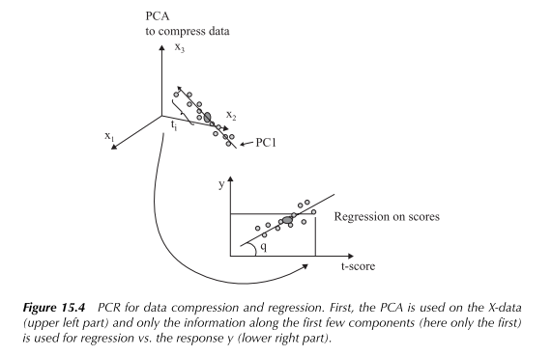
(C’è $\overline{y}$ perchè l’intercept coincide con il mean value in quanto mean centered i valori)
PRO: The PCR method solves the collinearity problem in an elegant way and provides a number of good tools for interpretation. It is also well understood theoretically (see e.g. Næs and Martens, 1988; Gunst and Mason, 1977, 1979) and has shown to perform very well both for prediction and interpretation in many practical applications also within sensory science. It is also easy to compute and easy to modify for more complex relations.
CON: a possible problem with the PCR is that all the components in model (15.17) are extracted based on $X$ only. This may be a drawback in situation where the first few components of $X$ have less relation to y than the components with minor variability. This is quite common in for instance spectroscopy, but in sensory science this effect is usually less important.
Therefore, for most purpose, the PCR will be sufficient for solving the collinearity problem and for providing useful tools for interpretation. A possible improvement over the PCR that has been proposed is the PLS regression method to be discussed in the next section
The same model can be used for several Y-variables, but as for MLR, the regression equations for the different Y-values are computed independently. How to determine the number of components to be used in Equations (15.17) and (15.18) will be discussed below in
Section 15.9 $→$ (MODEL VALIDATION, PREDICTION PERFORMANCE)
…
… how well the X-data can predict the Y-data?
- prediction testing;
which is based on splitting the data in two sets, building the model on one of them and testing it out on the other
- cross-validation; $↓$
If the data set is too small for splitting, cross- validation can be used instead. This is a method which does prediction testing several times, each time keeping one sample out of the data set, calibrating on the rest and testing it out on the single sample kept out.
A commonly used criterion for model quality is the root mean square error of prediction (RMSEP) defined by:
$$RMSEP=\sqrt{\frac{1}{N}\sum_{n=1}^{N}{{\left(y_{n}-{\hat{y}}_{n}\right)}^{2}}}$$
i.e. the square root of the averaged squared differences between the measured and predicted response value. Small values of the RMSEP are favoured since these indicate small differences between measured and predicted Y-value. Sometimes one uses the square value MSEP.
(…)
When concerns determining the best number of components for prediction purposes, one will usually repeat the prediction testing or cross-validation for several values of A and select the best solution. The values are often presented in a plot of the prediction error (RMSE) vs. the component number (Figure 15.6).
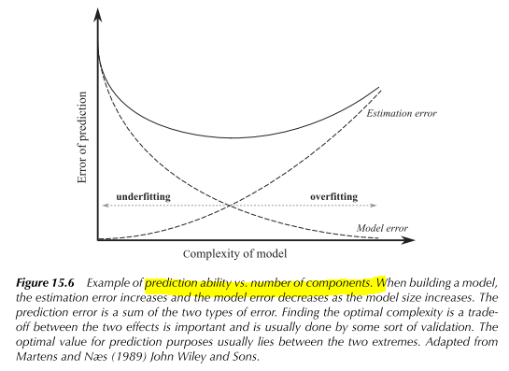
If two values of A give similar results one will normally select the model with the smallest number of components. The general tendency is that when using either too few (underfitting) or too many (overfitting) components, the prediction ability is poor. The optimal is usually in the middle representing a good compromise between the contributions from the estimation bias and estimation variance.
A statistical test has been developed for checking for significant difference between the prediction ability of two models (CVANOVA, Indahl and Næs(1998)). When focus is on the first few components for interpretation only, one is primarily interested in how much the two components explain in a cross-validation sense of the total variability.
It should be mentioned that in some cases, even the use of cross-validation may become complicated and even questionable. For very small data sets, and in particular when the samples are obtained using a designed experiment, each sample is unique, and it is often difficult to predict this unique information from the rest of the samples. The method of cross-validation is therefore best suited for situations where the samples span a natural space of variability and when the number of samples is not too small. Note that these considerations become more serious as the number of components increases. Even in situations where CV is not fully appropriate (see Chapter 9), the PCA and PLS scores and loadings can still be meaningful if one simply considers them as graphical representations of the data without any further generalisation property.
The (univariate)Partial Least square Regression (PLS).
The PLS regression (Martens and Næs, 1989; Wold et al., 1983) is based on the same general model structure as PCR (models (15.17) and (15.18)), the only difference is that the components $\hat{T}$ are computed in another way.
(…) The other way of computing components ensures that the components extracted are more relevant for the prediction of $y$ than the principal components. This may sometimes lead to models with a smaller number of components, which may possibly be easier to interpret, but from a prediction point of view the difference between the two methods is usually small.
For several Y-values, the PLS method is often referred to as PLS2.
PLS regression is easy to compute, in particular for the univariate case, where no iteration
is needed, it solves the collinearity problem and offers the same interpretation tools as for PCR. The tools are used the same way, so from a user’s point of view the two methods look very similar. The PLS algorithm also works for missing data. Also for PLS the use of bi-plots and correlation loadings is possible. The PLS method
can be extended to several blocks of variables in the same way as the PCA (see Tucker-1, Chapter 14), but this is not considered further here (Westerhuis et al., 1998).

[Science2010]Chapter17
(Useful methods for analysing the full set of individual sensory profile data)
SOME ALTERNATIVE METHODS that have been mentioned briefly elsewhere as extensions, generalisations or modifications of more basic methodology

- methods which are useful for analysing the full set of individual sensory profile data (NO)
In particular discuss generalised procrustes analysis (GPA) and three-way generalisations of principal components analysis, such as for instance PARAFAC and the different Tucker methods.

• Generalised Procrustes Analysis (GPA) NO
• Three-Way Generalisations of PCA
data compression methodology inspired by the PCA method (for the i-th assessor):
- Tucker-1 (a PCA of an unfolded matrix of data) 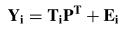 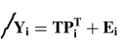
The solution for the first model is obtained by using PCA on the unfolded matrix with attributes as columns and products∗assessors as rows (Chapter 5). For second model, the same technique is used, but now for the unfolded matrix with products as rows and attributes∗assessors as columns (Chapter 3).
- Tucker-2 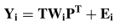
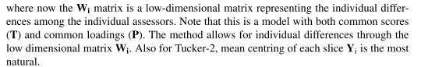
- PARAFRAC
model can be formulated as the Tucker-2 model with diagonal Wi matrices. The PARAFAC model can also be written for each of the elements in the Y-cube.
The concrete solutions for the three methods can all be considered as LS solutions (or approximate) using the Frobenious norm
• Generalised Canonical Analysis (GCA) NO
• The STATIS method NO
• Multiple Factor Analysis (MFA) NO
This is a technique which is closely related to Tucker-1. It is based on unfolding of the three-way structure such that the samples become the rows and the columns correspond to all the variables for all the data blocks (short and fat matrix). Then each of the blocks is divided by the eigenvalue of its own first principal component. This means that multiple factor analysis is essentially a Tucker-1 after a particular scaling.
$$↓$$
Use either PARAFRAC or one of the Tucker methods for the three-way data and then relate the common scores to the two-way data using PCR or regular PLS regression → CHAPTER 6
One method do both thing simultaneously is the Tucker-2 approach by substituting the common scores in the Tucker-2 model by a linear function of the external data, here called $X$ (so $T=XB$), so that the model becomes:
$$Y_{i}=XBW_{i}P^{T}+E_{i}$$
(dove $B$ è la matrice dei coefficienti della regression per capire, $W_{i}$ sono le “individual differences”)
If prediction equation is reversed, the multi-block PLS based on unfolding and direct use of PLS regression can be useful.
IF consumers are asked to quantify differences between the products. → 17.4 Multidimensional scaling
IF we must deal with rank data → 17.5 Analyzing rank data
POI
(INVESTIGATE ALSO IN)
Chapter 15 Multiple Regression, Principal Components Regression and Partial Least Squares Regression
Chapter 16 Cluster Analysis: Unsupervised Classification
…
…
…
…
…
…
…

Useful general background stuff

PCA and more….(from [bishop2006],[naes1996],[Science2010], )
[bishop2006](Section 12.1) → standard, non-probabilistic treatment of PCA
Principal component analysis, or PCA, is a technique that is widely used for applications such as dimensionality reduction. Dimension reduction methods transform the original features and then the model is learned on the transformed variables → this is what is under the conception of Tucker modelling BUT ALSO PCR, PLS later. Dimension reduction is an unsupervised learning approach There are many techniques to perform dimensionality reduction: Principal Component Analysis (PCA) (here).
There are two commonly used definitions of PCA that give rise to the same algorithm.
1. (Maximum variance formulation)
Principal component analysis can be defined as the orthogonal projection of the data onto a lower dimensional linear space. In other words, it seeks a space of lower dimensionality, known as the “principal subspace” such that the orthogonal projection of the data points onto this subspace maximizes the variance of the projected points.
If we have a dataset of observations $\left\{x_{n}\right\}$ with i=1,…,N and $x_{n}$ being a Euclidean variable with dimensionality $D$, PCA has the goal of projecting the data into the input subspace (having dimensionality $M<D$) which accounts for most of the variance.
- Find a line such that, when the data is projected onto that line, it has the maximum variance;
To begin we just consider the projection onto a one-dimensional space (M=1). We can define the direction of this space using a D-dimensional vector $u_{1}$, which for convenience, without loss of generality can be chose to be a unit vector such as $u_{1}^{T}u_{1}=1$ because we are only interested in the direction denoted by this vector.
Each data point $x_{n}$ is projected is then projected into a scalar value $u_{1}^{T}x_{n}=x_{n}u_{1}^{T}$ (scalar projection of vector $x_{n}$ onto $u_{1}^{T}$ which is a unit vector).
The mean of the projected data is $u_{1}^{T}\overline{x}$
where $\overline{x}$ is the sample set mean $\overline{x}=\frac{1}{N}\sum_{n=1}^{N}{x_{n}}$
The variance of the projected data is (by definition) given by: $\frac{1}{N}{\sum_{n=1}^{N}{\left\{u_{1}^{T}x_{n}-u_{1}^{T}\overline{x}\right\}}}^{2}=u_{1}^{T}Su_{1}$
where $S$ is the covariance matrix of the data $S=\frac{1}{N}\sum_{n=1}^{N}{{\left(x_{n}-\overline{x}\right)\left(x_{n}-\overline{x}\right)}^{T}}$
- Find a new line, orthogonal to the first one, that has maximum projected variance $u_{1}^{T}Su_{1}$ with respect to $u_{1}$;
This is a constrained ($u_{1}^{T}u_{1}=1$) maximization problem that can be solved through the use of a lagrange multiplier. If we solve the problem, the variance will be a maximum when we set $u_{1}$ equal to the eigenvector having the largest eigenvalue $λ_{1}$.(CI SONO IN INTERNET I CONTI DI QUESTA COSA) This eigenvector is known as the first principal component.
- Repeat until $m$ lines have been identified and project the points in the data set on these lines;
The next step is to search for the second principal component. This is done by the same procedure as for component number 1, but under the restriction that the direction of the second component is orthogonal to the first, i.e. that $u_{1}^{T}u_{2}=0$. Generally, the procedure continues by extracting new components that describe as much variance as possible under the restriction that each new principal component direction is orthogonal to the previous. This is done until the desired number of components are extracted.
We can define additional principal components in an incremental fashion by choosing each new direction to be that which maximizes the projected variance amongst all possible directions orthogonal to those already considered. If we consider the general case of an M -dimensional projection space, the optimal linear projection for which the variance of the projected data is maximized is now defined by the M eigenvectors $u_{1}, …, u_{M}$ of the data covariance matrix $S$ corresponding to the largest eigenvalues $λ_{1}, …, λ_{M}$.
SO, the precise STEPS of PCA are the following:
• Compute the sample set mean of the data: $\overline{x}=\frac{1}{N}\sum_{n=1}^{N}{x_{n}}$ (average of all the variables – is the larger point in the figure 14.2 below)
• Bring the data to zero mean by subtracting $\overline{x}$ (averages are subtracted form their corresponding variables, which corresponds to moving the origin of the coordinate system or the vector space to the average data point $\overline{x}$)
This is because, for any unit vector $\hat{u}$, assuming $X^{*}$ the data matrix after having centered the columns (so that mean here in the definition of variance is null), the variance after projecting along $\hat{u}$ is $E\left[{\left(X^{*}\hat{u}\right)}^{T}X^{*}\hat{u}\right]$. For the linearity of the expectation operator (acting on each component of these vectors) this is equal to ${\hat{u}}^{T}E\left[X^{*}{X^{*}}^{T}\right]\hat{u}={\hat{u}}^{T}cov\left[X^{*}\right]\hat{u}$. All these reasoning simply apply to the projected data above.
• Compute the covariance matrix of the data $S=\frac{1}{N}\sum_{n=1}^{N}{{\left(x_{n}-\overline{x}\right)\left(x_{n}-\overline{x}\right)}^{T}}$ and find the $M$ eigenvectors of $S$ corresponding to the $M$ largest eigenvalues (così corrisponde per via del problema di massimizzazione constrained risolto a massimizzare la varianza!)
- Eigenvector $e_{1}$ with largest eigenvalue $λ_{1}$ is the first principal component
- Eigenvector $e_{m}$ with $m^{th}$ largest eigenvalue $λ_{m}$ is the $m^{th}$ principal component
- $\frac{λ_{m}}{\sum_{i}{λ_{i}}}$ is the proportion of variance captured by the $m^{th}$ principal component
Then finding eigenvectors and eigenvalue can be done with dedicated well-known algorithms we can find in literature. Finding principal components is equivalent in solving an eigendecomposition problem for the covariance matrix. This is compliant with the well-known result of linear algebra that, in general, a linear transformation matrix is completely defined by its eigenvectors and eigenvalues and the covariance matrix can be interpreted as a linear operator that transforms white data into the data we observed. The full set of PCs comprises a new orthogonal basis for feature space, whose axes are aligned with the maximum variances of the original data and that are a linear combination of the original components.
2. An alternative definition of PCA is based on minimizing the sum-of-squares of the projection errors, that is, it can be equivalently defined as the linear projection that minimizes the average point cost, defined as the mean squared distance between the data points and their projection. For further details, refer always to [bishop2006].
Back in the context of our sensory data…

[Science2010] (Chapter14 Principal Component Analysis (PCA))
The method is particularly suitable in situations with lots of data and when little prior information is available. The PCA is based on the idea of finding the most interesting dimensions or directions of variability, called principal components. The idea behind the method as well as how to calculate the components will be discussed. The main results are presented in the scores plot, which describe the relation between the objects (rows in the data matrix) and the loadings plot, which describes the relations between the original variables (columns in the data matrix) and the principal components. These plots provide lots of information that can be used either for direct interpretation of the data set or as a preliminary step prior to further and more elaborate analyses. Rules for how to interpret the two plots will be given. Methods for validation and outlier detection will also be discussed.
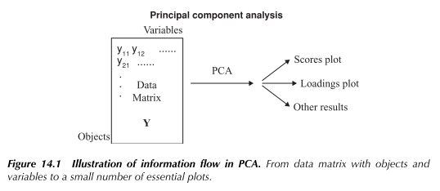
Typically PCA can be used for:
- early phase of an investigation as an explorative technique in order to provide an overview
- when classical solutions such as MLR LDA, QDA, etc., may be very unstable and give poor predictions (PCA is then useful for first compressing the information down to a few dimensions or components and then using only these few components in further analyses)
$↓$
EGUAGLIO LE NOTAZIONI:
(N oggetti, per ognuno dei quali l’osservazione è D-dimensionale)
If we have a dataset of observations $\left\{x_{n}\right\}$ with i=1,…,N and $x_{n}$ being a Euclidean variable with dimensionality $D$, PCA has the goal of projecting the data into the input subspace (having dimensionality $M<D$) which accounts for most of the variance. Expressed mathematically and generically, PCA transforms a data matrix $X$ (dim(X)= N x D), with N being the number of data points $x_{n}$ and D the dimension of data to an output $X^{'}=XP$ (dim($X^{'}$) = N x M with M$≤$D) where $P$ (D x M) is the projection matrix of which each column is a principal component (PC)—these are unit vectors that bear orthogonal directions. The input data matrix of N points is $X={\left[x_{1}, …,x_{N}\right]}^{T}$ where each $x_{n}$ is a D-dimensional vector. PCA finds a projection matrix P$={\left(u_{1},…, u_{M}\right)}^{T}$ that maps each point to a low-dimensional space M$≤$D.
IO DEVO TRASFORMARE LA DIMENSIONALITA’ D IN UNA DIMENSIONE MINORE!
Using $y_{nd}$ as the symbol for the observed value for the $d^{th}$ variable for object n, the data matrix can be written as MATEMATICAMENTE QUI SI CHIAMA $Y$ ANZICHE’ $X$ (PERCHE’ DI SOLITO LO APPLICO SULLA RESPONSE VARIABLE) MA VALGONO LE STESSE COSE (E USIAMO “D” ANZICHE’ “K” PER RIDURRE AL MINIMO
$$Y=\left(\begin{matrix}y_{11} & ⋯ & y_{1D} \\ ⋮ & ⋱ & ⋮ \\ y_{N1} & ⋯ & y_{ND}\end{matrix}\right)$$
For the use of PCA it is necessary to organize the data in a so-called data matrix where:
- each row in the table corresponds to an ‘object’
- and each column to a ‘variable’. (the D-dimensional observation for that particular object)
Then, the columns and rows may have different meaning dependent on application area
There is also the possibility for dealing with missing values…
The PCA is based on the idea of identifying the directions in the multivariate variable space with the highest possible variance.
NOTE THAT! If we would extract, in principle, all the possible components, the PCA can be considered simply as a full rotation of the original variables (or as a change of co-ordinate system). Often, however, the relationship among the variables is so strong that only a few components, for instance 2 or 3, are needed in order to explain a substantial amount of the total variance in the data set.
EXAMPLE:
D=3
N = 20 observation of 3D values
GRAPHICALLY (from [Science2010]) In the figure, each row is represented as a point (vector) in the three-dimensional coordinate system
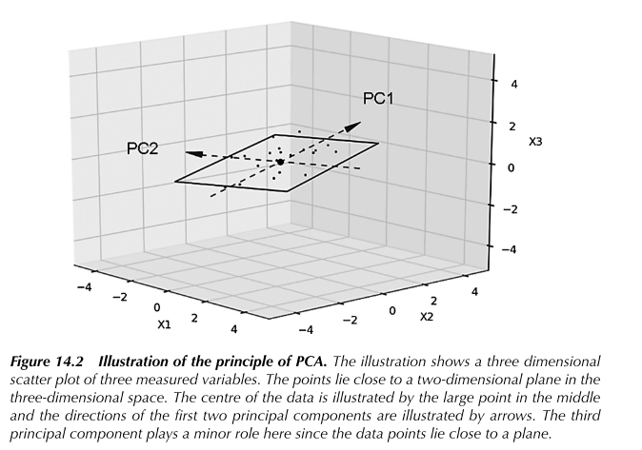
The first step of the PCA is to compute the average of all the variables. This average is plotted in Figure 14.2 as a larger point than the rest. Then the averages are subtracted from their corresponding variables which corresponds to moving the origin of the coordinate system or the vector space to the average data point $\overline{y}$ (in the figure is called $x$ no one knows why )
The second step is to search for the direction in space that has as large variance as possible: this corresponds to finding the direction defined by the unit vector $u_{1}$ (OLD NOTATION) ${\hat{p}}_{1}$ (BOOK NOTATION) which goes through the average point $\overline{y}$ (project all rows of the dataset into this direction) and which goes in the direction with as much variability as possible.
(ABOUT “LOADINGS” AND “SCORES”)
WITH PREVIOUS NOTATION
If we consider an arbitrary direction denoted by the unit vector $\hat{u}$ through the mean and project all the data points $y$ into this direction (rows in the dataset, quindi ogni vettore nello spazio D-dimensionale), generally speaking, the projection of such data vector(s) (projection of all rows of the dataset) can be written as a product of this unit vector and a coordinate: $u\hat{u}$.
The first principal component direction is thus identified by ${\hat{u}}_{1}$ and is defined as those directions for which the variance of the coordinate (projected data!)$u$ becomes as large as possible.
Then the second principal component direction by ${\hat{p}}_{2}$ ecc… (remember that, at the end, PCA finds a projection matrix P$={\left({\hat{u}}_{1},…, {\hat{u}}_{M}\right)}^{T}$) (where each $u_{1}$, …, $u_{M}$ is a vector with all its components (or scores as seen below!)
It can be shown that the coordinate(s), usually called the score(s) or value(s) (for a generic principal component) can be written as $u={\hat{u}}^{T}y=y^{T}\hat{u}$ (as dot product is symmetric)(the usual scalar projection) which is simply a linear combination of the original measurements.
The elements of ${\hat{u}}_{m}$ (m=1,…,M < D) are called the loadings values for the m-th component and, as can be seen, they define the contribution of each of the original variables in the calculation of the m-th score. A high loading value for instance for variable 1, means that the first principal components is strongly related to variable 1
The elements of the vector $u_{1}$ are the loadings for component 1, The elements of the vector $u_{2}$ are the loadings for component 2, etc…
WITH THE NOTATION OF THE BOOK:
If we consider an arbitrary direction denoted by the unit vector $\hat{p}$ through the mean and project all the data points $y$ into this direction (rows in the dataset, quindi ogni vettore nello spazio D-dimensionale) generally speaking, the projection of such data vector(s) (projection of all rows of the dataset) can be written as a product of this unit vector and a coordinate: $\hat{t}\hat{p}$.
The first principal component direction is thus identified by ${\hat{p}}_{1}$ and is defined as those directions for which the variance of the coordinate (projected data!)$\hat{t}$ becomes as large as possible.
Then the second principal component direction by ${\hat{p}}_{2}$ ecc… (remember that, at the end, PCA finds a projection matrix P$={\left(p_{1},…, p_{M}\right)}^{T}$) (where each $p_{1}$, …, $p_{M}$ is a vector with all its components (or scores as seen below!)
It can be shown that the coordinate(s), usually called the score(s) or value(s) (for a generic principal component) can be written as $\hat{t} ={\hat{p}}^{T}y=y^{T}\hat{p}$ (as dot product is symmetric)(the usual scalar projection) which is simply a linear combination of the original measurements
The elements of $p_{m}$ (m=1,…,M < D) are called the loadings values for the m-th component and, as can be seen, they define the contribution of each of the original variables in the calculation of the m-th score. A high loading value for instance for variable 1, means that the first principal components is strongly related to variable 1
The elements of the vector $p_{1}$ are the loadings for component 1, The elements of the vector $p_{2}$ are the loadings for component 2, etc…
………………………………
…… (examples)……
………………………………
For a generic observation vector $y_{n}$ (row in the dataset):
${\hat{t}}_{1}={{\hat{p}}_{1}}^{T}y_{n}$ (or $u_{1}={{\hat{u}}_{1}}^{T}y$) is the score (coordinate) for the first principal component for the n-th observation vector (with ${\hat{p}}_{1}$ (or ${\hat{u}}_{1}$) first direction of maximum variance)
${\hat{t}}_{11}={{\hat{p}}_{1}}^{T}y_{1}$
${\hat{t}}_{12}={{\hat{p}}_{1}}^{T}y_{2}$
(…)
${\hat{t}}_{1N}={{\hat{p}}_{1}}^{T}y_{N}$
${\hat{t}}_{2}={{\hat{p}}_{2}}^{T}y_{n}$ (or $u_{2}={{\hat{u}}_{2}}^{T}y$) is the score (coordinate) for the second principal component for the n-th observation vector (with ${\hat{p}}_{2}$ (or ${\hat{u}}_{2}$) the second direction of maximum variance)
${\hat{t}}_{21}={{\hat{p}}_{1}}^{T}y_{1}$
${\hat{t}}_{22}={{\hat{p}}_{1}}^{T}y_{2}$
(…)
${\hat{t}}_{2N}={{\hat{p}}_{1}}^{T}y_{N}$
(…)
Ci sarà uno score
SO THE NEXT STEP IS SEARCHING FOR THE SECOND PRINCIPAL COMPONENT (AND SO ON… SEE BOOK $→$) (directions have the constraint to be orthogonal etc…)
QUINDI:
The score for the FIRST principal component for one of the objects with observation vector $y_{n}=\left[y_{n1},…,y_{nD}\right]$ can be written as a linear combination its elements:
$${\hat{t}}_{1}=y^{T}{\hat{p}}_{1}=\sum_{d=1}^{D}{y_{d}{\hat{p}}_{d1}}$$
(qui sto rimuovendo il subscript n dalla generica observation (e sfruttando la commutatività del prodotto scalare))…
The score for the m-th principal component for one of the objects with observation vector $y_{n}=\left[y_{n1},…,y_{nD}\right]$ can be written as a linear combination its elements:
$${\hat{t}}_{m}=y^{T}{\hat{p}}_{m}=\sum_{d=1}^{D}{y_{d}}{\hat{p}}_{dm}$$
(qui sto rimuovendo il subscript n dalla generica observation (e sfruttando la commutatività del prodotto scalare))…
This is nothing but the projection of the vector $y_{n}$ onto the space defined by the vector $p_{m}$.
m=1,…,M are the principal components
n=1,…,N are the number of data points
d=1,…,D is the dimensionality of each data point vector
Ad esempio, con il data point (un oggetto) n=1, lo score per la componente principale m=1 lo scrivo come combinazione lineare. NOTA che $p_{m}$ ha dimensione D perchè anche lui rappresenta praticamente una direzione ruotata in uno spazio D-dimensionale.
RIMOUVO LA NOTAZIONE CON IL CAPPUCCETTO ADESSO
The full set of principal component scores, is given by the atrix product:
$$T=YP$$
And, accordingly to what defined above, $P$ is called the “matrix of loadings” P$={\left(p_{1},…, p_{M}\right)}^{T}$ (with rows corresponding to the variables and columns to the components)
IF WE INVERT (la trasposta coincide con l’inversa sotto alcune condizioni) the previous equation, when all possible components have been extracted:
$$Y=TP^{T}=\sum_{d=1}^{D}{t_{d}p_{d}^{T}}$$
Where $t_{d}$ are the columns of $T$ and $p_{d}$ are the columns of $P$. This equation basically shoes how the data matrix can be written as a linear combination of the principal components.
This formula is essentially the same as the singular value decomposition (SVD) of the matrix $Y$ (Mardia et al., 1979). This means that principal components scores and the loadings vectors can be found as eigenvector of the $YY^{T}$ and $Y^{T}Y$ matrices respectively. The explained variances of the components correspond to the eigenvalues of the matrices.
If we decompose that equation into two contributions:
$$Y=\sum_{d=1}^{D^{'}}{t_{d}p_{d}^{T}}+\sum_{D^{'}+1}^{D}{t_{d}p_{d}^{T}}=\sum_{d=1}^{D^{'}}{t_{d}p_{d}^{T}}+E=T_{1}P_{1}^{T}+E=\hat{Y}+E$$(Equation (14.6) accorpata e scritta meglio del libro)
Where the first part corresponds to those components that describe most of the variation in $Y$ and which usually are the most important ones for plotting and the last part is the rest of the components, often considered as noise and denoted by $E$. In other words, one can consider the matrix $Y$ as composed into a contribution from a few major principal components plus noise.
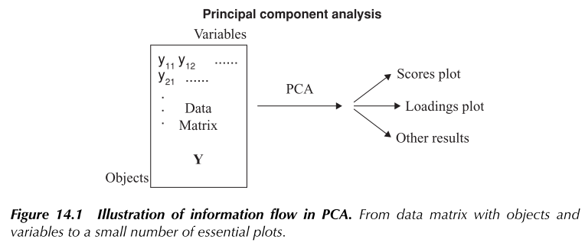
The PCA is based on the idea of finding the most important directions of variability in the high-dimensional space of all the measured variables and presenting the results in plots that can be used for simple interpretation.
We know that PCA is based on the idea of finding the most interesting dimensions or directions of variability, called principal components. As far as these plots are concerned, usually, two-dimensional plots based on the two first components are used.
The main results are presented in the:
• the scores plot: describe the relation between the objects (rows in the data matrix $Y$) → This is basically a scatter plot of the column of $T$
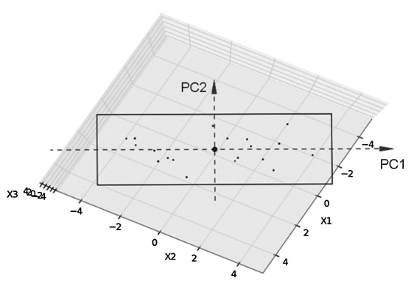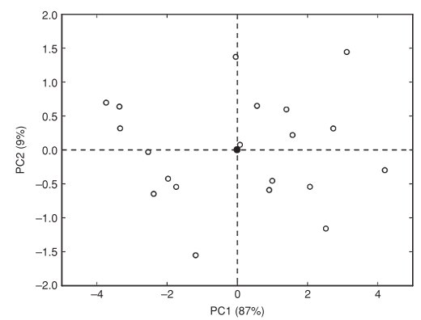The scores plot is therefore simply a plot of the relation between the objects in the projected space.
• the loadings plot: describe the relations between the original variables (columns in the data matrix $Y$) and the principal components → This is basically a scatter plot of the column of $P$
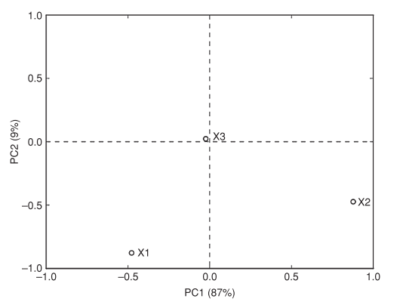
The loadings plot is a plot which shows the relation between the original variables and the principal components themselves. Variables with a large loading value will show up far away from the origin in the plot and variables with a small loading will fall close to the origin. Variables far from the origin in one of the directions/components only, are variables that load strongly for that particular component. This means that these variables are important for that particular component, but not for the others.
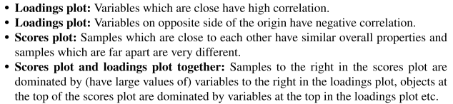
A modification of the above regular loadings plots, called the correlation loadings plot, was proposed in Martens and Martens (2001) (see also Mardia et al., 1979). It is a two-dimensional scatter plot based on the idea of plotting the correlations between the components and the variables themselves instead of the loadings as they are.
The correlation loadings plot also opens the possibility of drawing circles in the plot corresponding to various degrees of explained variances (See Book →)
Standardization and sensory analysis……
The only purpose of PCA is to look for directions with high variance. This means that if there are some variables that have a larger variance than others, they will be given the most attention and dominate the components extracted and then also the plots. This may be natural in some cases, but generally one is interested in letting all variables play a role in the estimation of components. A way to obtain this is to divide all variables by their own standard deviation ending up with variables that all of them have the same standard deviation equal to 1. For sensory and consumer data, the standardization may have a certain effect, but since variables are measured on more or less the same scale, the impact of standardization will often have only a moderate effect on conclusions drawn from the study. The plots may be slightly different, but the overall conclusions will often be similar. Some more specific aspects for sensory and consumer data are given next. Here we will also discuss briefly centring and not centring before PCA which may possibly be an issue in particular for consumer data.
The comments given here hold regardless of whether one uses PCA on the average sensory profiles or on the unfolded matrix of individual sensory profiles (see Tucker-1 THEN). For sensory analysis:
- mean centering is always done for each attribute
- eliminate the variables that do not significantly distinguish between the products before standardization. This can always be done by the use of two-way ANOVA as is discussed in Chapters 5 and 13 if two or more replicates are used
if some of the variables have a small variance and this is due to the fact that there is no or very little significant information in them, automatic standardising will ‘blow up’ the noise in these variables and make the noise equally important as the more informative variables in the rest of the sensory profile. Such variables may have an unfortunate effect on the PCA solution. Therefore, it is a sensible practice to eliminate the variables that do not significantly distinguish between the products before standardisation.
- standardization is often done (usually only a moderate effect on the conclusion drawn)
It is important to emphasise that the variables after standardisation have a slightly different interpretation than before standardisation. Performing a standardisation implicitly assumes that the original length of the scale used for the different attributes have no direct interpretation and meaning. In other words, differences in range for the different attributes are considered as uninteresting and only due to the calibration of the panel. NO!!
A method with attractive numerical properties for situations with missing values is the NIPALS method (Wold, 1982). This is based on a series of simple regression models, and in each step one simply skips those observations or cells that are missing.
Crossvalidation (or, in a simpler fashion, leaving aside a certain percentage of data for prediction testing) can be also applied to PCA to determine how many PCA components can be looked at safely (…)
The simplest tool for detecting outliers and also for detecting the most influential observations is the scores plot. If there are samples which are positioned far from the centre as compared to the rest, these are obvious candidates for further study. If there are many components to look at, it may be helpful to support this search by the so-called leverage which is a measure of the distance from a sample to the centre (…).
Validation
In regression analysis (Chapter 15) empirical validation of models is very important for the purpose of getting information about how good the model is for prediction. In the following we will discuss briefly how these methods can be used for determining how many PCA components that can be looked at safely. In most cases one will use only 2 or 3 components, but even for this small number of components one is interested in how reliable the components are.
The most fortunate situation to be in from an empirical validation point of view is when the samples are selected at random from a population of samples and the number of samples is reasonably large NOT OURS!! In this case one can use
- cross-validation (CV)
- prediction testing (see Chapter 15) to get an idea of the importance or significance of the different components extracted.
Both of these methods are based on the idea of modelling some of the samples in the data set (training data) and testing out on some others (test data). Prediction testing is the best and simplest, but requires that a number of objects (for instance 30 %) are set aside for testing only. Cross-validation, based on leaving one or a few samples out in sequence, is more appropriate when the number of samples is small. For both methods the testing is done by calculating the residuals after fitting of the test vectors y to the loadings
(…)
In situations with a small set of samples or samples based on an experimental design, the prediction testing and CV are more problematic to use. The reason for this is that each sample is unique and it is not necessarily possible that each sample fits into the model determined by the rest of the samples. In such cases other methods may be more useful for obtaining information about validity of the components for interpretation purposes.
- One possibility is to look at the explained variance for different number of components when fitting the model. If this explained variance curve goes up in a steep way before coming to a point where it clearly flattens out, this point is an indication of where one should stop interpreting components.
- Another important ‘tool’ is interpretation itself. If the interpretation makes sense in terms of previous knowledge or the design behind the study, this is a good argument for validity of the results. In some cases, one may also have prior knowledge regarding for instance correlation structure among variables and/or similarity between samples, which can be useful.
- An alternative type of CV for PCA was proposed in Wold (1978) where observations were removed according to a certain pattern in the data table. One should, however, always remember that in practice it is difficult to interpret more than 2–3 components.
(…) OUTLIER DIAGNOSTICS

Towards the Tucker-1 method… PCA ON THREE-WAY DATA
What happens if the original data has a “three-way structure” and is not a well-defined two-dimensional matrix? To use PCA on this type of data, one needs to unfold the data first. The slices for the different assessors can be either set beside each other or under each other.
•SITUAZIONE 1: unfoldo per avere una matrice con J righe (samples) e I*K colonne (different assessor-attribute combination)
→ give rise to PCA models (QUELLO VISTO FINO A ADESSO SOPRA come in (14.11))
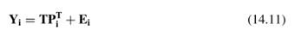
This is a common scores model allowing for different loadings for the different assessors
The first model is the one used for analysing individual sensory data for the purpose of detecting individual differences in Chapter 3 (SEE FIGURE THERE)
Era usato questo qui del (14.11) nel contest del Chapter 3 per Overall Assessment of Assessor Differences Using All Variables Simultaneously After elimination of unimportant variables by the use of mixed model ANOVA. Qui $P_{i}^{T}$ represents the matrix with the loadings for assessor number $j$. As can be seen, the scores $T$ are common for all assessors, only the loadings are different!
•SITUAZIONE 2: unfoldo per avere una matrice con I*J righe (different assessor-samples combination) e K colonne (columns corresponding to the different attributes)
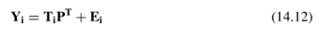($↑$)
The second one is a common loadings model allowing for different scores.
. ($↑$)The second one is the one used in the PC-ANOVA (Chapter 5)* where the purpose is to relate the scores to external data.
IN BOTH MODELS:
$Y_{i}$ represents the data matrix for the $i^{th}$ assessor.
$TP^{T}$ part describes the most important components
$E$ represents the rest, usually thought of as noise.
Using PCA on this type of data set is often called Tucker-1 according to the author of the first publications in the area (Tucker, 1964, 1966). The method is also known under the name of consensus PCA (CPCA. Westerhuis et al., 1998).
The results from a Tucker-1 method are presented in scores plot and loadings plot. For assessor evaluation purpose, the correlation loadings are often used.

The Relation between PCA and Factor Analysis (FA)
Aa
[https://www.theanalysisfactor.com/the-fundamental-difference-between-principal-component-analysis-and-factor-analysis/]
[https://stats.stackexchange.com/questions/1576/what-are-the-differences-between-factor-analysis-and-principal-component-analysi]
Principal component analysis involves extracting linear composites of observed variables.
Factor analysis is based on a formal model predicting observed variables from theoretical latent factors.
In terms of a simple rule of thumb, I'd suggest that you:
- Run factor analysis if you assume or wish to test a theoretical model of latent factors causing observed variables.
- Run principal component analysis If you want to simply reduce your correlated observed variables to a smaller set of important independent composite variables.
[https://www.researchgate.net/post/Factor_analysis_Vs_PCA]
They are both attempts to reproduce covariance or correlation matrices using matrices of lower rank. PCA focusses on the diagonal of the covariance matrix, trying to capture as much as possible of the variation in the data by means of a small number of linear combinations of the variables. PCA is by its very nature scale-dependent: if you change the scale of one variable, say from billions to cents, to take a very extreme example (blowing up its variance by 10^22), and the other variables remain in billions of dollars, the first variable will typically be responsible for most of the variation, and per force will be your first principal component. It is customary to standardize the variables before doing a PCA.
Factor analysis aims to reproduce the off-diagonal elements of the covariance matrix S, say, as well as possible. It essentially tries to find a diagonal matrix D, say, with positive elements such that S-D is a matrix with a low rank. If successful, one could then say that the correlation between the variables can be explained by a small number of underlying latent factors (and the diagonal elements of D are interpreted as the variances of the measurement errors).
Having said that, numerically they may yield similar results. A systematic analysis is provided by H. Schneeweiss & H. Mathes (1995): Factor Analysis and Principal Components. Journal of Multivariate Analysis, 55, 105-124. It is also rewarding reading for the very question you raised. There are models that allow of relationships between the underlying variables, be it principal component type of variables (cf. Partial Least Squares) or latent factors (LISREL etc). Here too there are circumstances where they yield similar results, or where the first can be adapted to yield results close to the second.

Concept of projection Matrix and intuitive application to PCA
The vector projection of $b$ on $a$ is a vector $b_{1}$:
$$b_{1}=b_{1}\hat{a}=\left(\left\|b\right\|\cos{θ}\right)\hat{a}=\left(\left\|b\right\|\cos{θ}\right)\frac{a}{\left\|a\right\|}$$
The magnitude is the scalar projection of $a$ on b with the same direction as $b$ denoted by the unit vector $\hat{b}$. When $θ$ is not known (remember that dot product is commutative):
$$\cos{θ}=\frac{a⋅b}{\left\|a\right\|\left\|b\right\|}=\frac{b⋅a}{\left\|a\right\|\left\|b\right\|}$$
So that the definition of vector projection becomes:
$$b_{1}=\frac{b⋅a}{\left\|a\right\|}\frac{a}{\left\|a\right\|}=\left(b⋅\hat{a}\right)\hat{a}=\frac{b⋅a}{{\left\|a\right\|}^{2}}a=\frac{b⋅a}{a⋅a}a=\frac{a⋅b}{a⋅a}a$$
where ${\left\|a\right\|}^{2}=a⋅a=a_{1}^{2}+…+a_{n}^{2}$=$a^{T}a$ and $a⋅b=a^{T}b=a_{1}b_{1}+…+a_{n}b_{n}$. Then, as at the numerator the dot product produces a scalar number we can re-write the expression commutatively:
$$b_{1}=\frac{1}{a⋅a}a\left(a⋅b\right)=\frac{1}{a^{T}a}a\left(a^{T}b\right)$$
Since matrix multiplication is associative, we can regroup this as:
$$b_{1}=\frac{1}{a^{T}a}\left(aa^{T}\right)b=\left(\frac{aa^{T}}{a^{T}a}\right)b=P_{a}b$$
where $\frac{1}{a^{T}a}$ is a scalar, $aa^{T}$ is a matrix and $b$ is a vector. Note that the scalar factor can be absorbed into the projection matrix. In this way, this operation act like a normalization; in other words, the resulting matrix represents orthogonal projection onto (the span of) $a$. Of course, vectors and matrices are expressed relative to a basis that’s orthonormal with respect to the dot product here.
A projection matrix $P_{a}$ is basically a linear operator (from a vectorial space onto a vectorial space) such that $P_{a}^{2}=P_{a}$ and (of course) $P_{a}a=a$. In the above derivation of projection onto $a$, $b$ is an arbitrary vector, so, for all $b$, the $Pb$ is some scalar multiple of $a$. In other words, the image (column space) of $P_{a}$ is spanned by $a$ – it is the line through $a$ – and so the rank of $P_{a}$ is 1. This can also be seen by examining $aa^{T}$ directly: each column is a multiple of $a$ (see right below). In fact, the orthogonal projection can be represented by a projection matrix. To project a vector onto the direction of the unit vector $\hat{a}$, we have, for example in the context of the Euclidean space $R^{3}$ that the projection matrix is $P_{a}=\left(\frac{1}{a^{T}a}\right)aa^{T}=\frac{1}{a^{T}a} \left[\begin{matrix}a_{x}^{2} & a_{x}a_{y} & a_{x}a_{z} \\ a_{x}a_{y} & a_{y}^{2} & a_{y}a_{z} \\ a_{x}a_{z} & a_{y}a_{z} & a_{z}^{2}\end{matrix}\right]$.
In the context of PCA, principal component analysis in essence, is a linear projection operator that maps a variable of interest to a new coordinate frame where the axes represent maximal variability. Expressed mathematically and generically, PCA transforms a data matrix $X$ (dim(X)= N x D), with N being the number of data points $x_{n}$ and D the dimension of data to an output $X^{'}=XP$ (dim($X^{'}$) = N x M with M$≤$D) where $P$ (D x M) is the projection matrix of which each column is a principal component (PC)—these are unit vectors that bear orthogonal directions.
The input data matrix of N points is $X={\left[x_{1}, …,x_{N}\right]}^{T}$ where each $x_{n}$ is a D-dimensional vector. PCA finds a projection matrix P$={\left(u_{1},…, u_{M}\right)}^{T}$ that maps each point to a low-dimensional space M$≤$D. As described above, each u is a basis vector that maximizes the variance of $X$ in orthogonal directions with respect to each other, and that amount of variance preserved decreases from $u_{1}$ to $u_{M}$. In fact, what is understood by variance in several dimensions ("total variance") is simply a sum of variances in each dimension. Mathematically, the total variance of a dataset is the trace of the covariance matrix. This definition has various nice properties, e.g. trace is invariant under orthogonal linear transformations, which means that if you rotate your coordinate axes, the total variance stays the same.
The full set of PCs comprises a new orthogonal basis for feature space, whose axes are aligned with the maximum variances of the original data and that are a linear combination of the original components. The projection of the original data into the first $M$ principal components (P$={\left(u_{1},…, u_{M}\right)}^{T}$) gives a reduced dimensionality representation of the data: $X^{'}=XP$. Of course, transforming the reduced dimensionality projection back into the original spaces gives a reduced dimensionality reconstruction of the data, but with some error. This error can be small and often acceptable given the other benefits of dimensionality reduction.

OUR SOLUTION
In [olive2004I] lui lo fa per il single speaker un modello e predicendo un solo attributo

Improving panel before multivariate regression (Chapter4)
[Science2010] “IMPROVING SENSORY PANEL DATA”(Data pretreatment)
These aspects Chapter 4 in connection with how to improve sensory panel data (improving sensory profile data) → Unreliable assessors, in the sense that they provide very noisy data or are very different from the rest can reduce the validity of sensory panel averages.
What should we do with data from assessors that are less reliable than the others?
How we could pre-process data before averaging?
pre-processing of data before three-way analysis.
$$↓$$like to use the data at hand, for instance for computing panel averages, even if some of the assessors are different from or less reliable than the rest.
In this chapter main attention of attribute-wise pre-processing methods before ANOVA or averaging over assessors
If differences in reliability are detected, it may be natural to weigh down the most unreliable assessors when computing the panel average.
Differences in use of the scale are not directly related to the reliability of the assessors, but it may be important to correct for them before averaging in order to make the data comparable across assessors.
FIRST
obtain a scaled dataset(CORRECTING FOR THE USE OF THE SCALE)
The structure of the data considered here is the same as used in Chapter 3 and depicted in Figure 2.1 (J samples, I assessors and K attributes). In some cases also external data of the same samples (J samples) will be used.
It may therefore sometimes be advantageous to pre-process the data before further analysis, being it ANOVA or multivariate analyses based on panel averages (see Chapter 6) (Note that when applying ANOVA methods, correction for position is done automatically if an assessor effect is incorporated in the model).
$→$ IN OUR ANOVA MODEL THE ASSESSOR IS THE ONLY EFFECT
Different ways to obtain a scaled dataset:
The simplest method for reducing differences in range is to divide scores for each assessor and attribute combination by the corresponding standard deviation, i.e. standard deviation obtained across samples and replicates. This means that for each combination of attribute (k) and assessor (i) one computes the quantity:
$$y_{ijkr}\left(new\right)=\frac{y_{ijkr}\left(new\right)}{s\left(y_{ik}\right)}$$
Where the standard deviation $s\left(y_{ik}\right)$ is taken over all samples and replicates. Usually, the data will be centred for each individual prior to the transform.
- Slightly more complex method: scale the different assessors with the purpose of making them as similar as possible in a least squares (LS) sense.
…………In chapter 3 (3.5.2 “Minimising Differences between Assessor Scores for the Same Product and Attribute”) (…) another method based on a mathematical technique: the average scores (over replicates) $y_{ijk}$ for assessor I, product j and attribute k are all multiplied by a costant $c_{ik}$ independent on the samples $j$ (CHE PER NOI SONO O TRACCIA O SPEAKER, GUARDA IN VERTICALE) which are optimized such that the scores for all products and attributes become as similar as possible. The optimization is done for each attribute (k) separately using the criterion:
$$Criterion\left(k\right)=\sum_{j=1}^{J}{\sum_{i<i^{'}}{{\left(c_{ik}y_{ijk}-c_{i^{'}k}y_{i^{'}jk}\right)}^{2}}} \left(3.2\right)$$
In order to obtain a non-trivial solution, a restriction is put on the c-values (see Naes(1990) for details). The algorithm for finding the solution is simple and based only on simple eigenvector calculations. The advantageof this method as opposed to the method above is that is also offers diagnostic procedures.
For example, one can look at the individual contributions to the sum to identify assessors that do not fit the rest. Negative constants $c_{ik}$ are indications of attribute-assessor combinations for which the order of samples is reversed, thus indicating a confusion or very large random noise.
……… HERE the criterion to minimise for this procedure is the same as used in Equation (3.2) After estimation of the correction constants, new data are obtained by multiplying the original score values by the estimated values. Figure 4.1 shows the scaling constants for a concrete example with 6 attributes and 10 assessors. The scaling constants minus 1 are presented in order to highlight the differences between those values which are higher and those that are lower than 1. A scaling constant equalling 1 corresponds to no change. The values are sorted according to assessor.

- Martens (2008) has proposed to use a method inspired by the MSC transform (Geladi et al., 1985) for spectroscopic data for the purpose of reducing scaling differences

- Fitting the Brockhoff model to the data and then computing the differences between the raw data and the predicted values from the model (the residuals) thus obtaining corrected data to be used for further analysis

THEN
(When computing a weighted average, it will here always be assumed that the data have been scaled by one of the methods above prior to averaging)
computing improved panel averages:
Unreliable assessors, in the sense that they provide very noisy data or are very different from the rest, can reduce the validity of sensory panel averages. In such cases it may be tempting to reduce their influence by giving them less weight when computing the panel average (QUINDI DOPO AVER GIA’ RIMOSSO L’OUTLIER PER NOI)
THE GENERAL WEIGHTED AVERAGE FORMULA for the weighted average profile for sample j can then be written as:
 
Here $\hat{y}$ represents raw data (EVENTUALLY here averaged over replicates) or raw data that have been smoothed before averaging as will be discussed below.
Note that setting one of the assessor weights equal to 0 corresponds to eliminating that assessor from the new weighted average. Note also the resemblance between this and weighted least squares fitting based on estimated weights (iteratively reweighted regression (Weisberg, 1985).
SO, we can compute improved panel averages by computing a weighted average, where the weights $w_{ik}$ are computed according to one of the criteria to be discussed below:
For computing the weight, we therefore recommend the use either relations to the average profile or differences between replicate measurements. (NOI NON ABBIAMO REPLICATE MEASUREMENTS)
A POSSIBLE WEIGHT COULD BE:
- Correlation coefficient between an average assessor and the average profile (possibly with the actual assessor eliminated)
Assessors with a weak relation to the average will thus be weighted down.
Assume the average profile to be:
$$X=\frac{1}{I} \sum_{i}{X_{i}}$$
If the matrices $X_{i}$ are the $I$ matrices of ratings for each assessor /
/
Another possibility is to use 1 divided by a function of the standard deviation of the random noise. A standard deviation of the noise can be obtained by pooling standard deviations of the replicated measurements for each sample/assessor/attribute combination or by using residuals from a Tucker-1 modelling (see Chapter 14) of the raw data. The Tucker-1 method has the advantage that one does not use explicitly the information about which observations that are replicates.

- STATIS (see [naes1996] on CHAPTER 17)
The method automatically weighs the contributions of the different matrices by using the so-called RV coefficients. This is an index measuring the degree of correspondence between data matrices and in this way can be used to put less emphasis on the individuals which are most different from the rest.
STATIS ends up with a consensus matrix representing a type of average for all the assessors.
This matrix can be used like regular average data matrices as described in for instance Chapter 6

$↓$
[naes1996]
The STATIS method is another method for individual profile data which looks for similarities and differences. This method is treated in Chapter 9. The method is based on maximizing correlations among the profiles and provides plots/maps of a similar type as most other methods treated in the book.
(CHAPTER 9) “Defining and validating assessor compromises about product distances and attribute correlations”
A noi in questo contesto ci interessa la risposta alla domanda:
How can the similarity between two individual sample spaces be measured?
The basis of this framework is the RV coefficient, more specifically, STATIS is a non-iterative 3-way multivariate analysis, based on the RV coefficient, which defines a compromise among assessors about the sample differences.
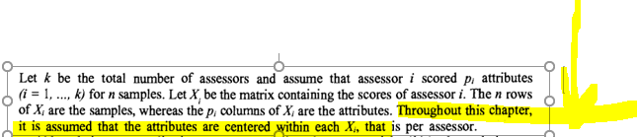
The question of choosing the attribute weight system, also called metrics, is more important. Metrics is a way of computing distances between samples. Generally speaking, it is a positive symmetric matrix Q of size p (the number of attributes). As Q can be different among the assessors, sometimes it will be called $Q_{i}$.

the association matrix $W_{i}=X_{i}X_{i}^{'}$ contains the full information about the multidimensional differences among samples found by subject i. The association matrices are the basis of the subject comparisons in STATIS, which can therefore be done even if the assessors did not score the same attributes.
(…)
2.4. Comparing two individual sample spaces by means of the RV coefficient
The quantity: $(1)$
is the natural scalar product between two matrices, where $w_{lm}^{i}$ is the (l,m)-th element of matrix $W_{i}$.
The quantity: (2)
In this context, the RV coefficient is  (3)
(generalised correlation coefficient between $W_{i}$ and $W_{j}$ matrices)
The closer the RV is to 1, the more similar assessors i and j are in terms of their standardized product distances
(………) In comparing two assessors, while (1) depends on the use of the scale, the generalized correlation in (3) is better. (………) Reader must understand that this matrix standardization is different from the classical attribute standardization, which is done by a PCA of correlation matrix. Contrarily to this normalized PCA, RV takes into account the differences between attribute variances for a given assessor. (………) RV coefficient is a measure of the similarity between two individual sample spaces. RV is the classical correlation coefficient between the two square matrices of sample scalar products of size (n,n) having been previously arranged within two vectors of size $n^{2}$.
2.5. Testing significance of a RV coefficient by an exact permutation test of the products
$→$is the agreement between the two assessors is better than what can be obtained by chance??
because the magnitude of a RV coefficient depends on both the number of observations and the number of variables in the two data sets, there is a need for a statistical test of RV significance. An exact non parametric permutation test is available, it makes it possible to declare whether two assessors agree more than what can be just obtained by chance (SALTA QUESTA PARTE)
2.6 Defining and interpreting a compromise sample space among the assessors by means of the STATIS method

The STATIS compromise W differs from this natural compromise W, because the latter is a classical mean, whereas the STATIS compromise is a weighted mean of the $W_{i}$:
$$W=\sum_{i}{a_{i}W_{i}}$$
Where ${\left(a_{i}\right)}_{i=1,…,k}$ is the first eigenvector of the matrix of size (k,k) containing the RV coefficients between assessors.
(HO
The components of this vector are positive and normalized to get a sum equal to one. This vector represents the "principal agreement among assessors". Thus, the greater the $a_{i}$, the more assessor i agrees with the panel on the sample differences. The strategy of STATIS is therefore to put weights on subjects proportionally to their agreement with the panel. Therefore, the weight of an outlier should be close to 0.

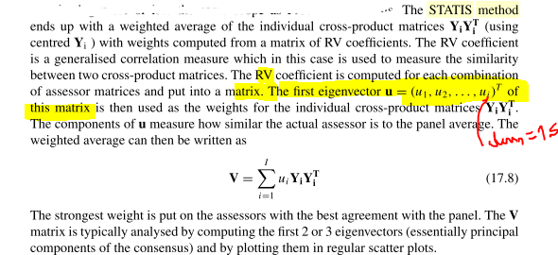
PER APPLICARE POI DOPO:
RV coefficient and STATIS work with any set of product weights (the same for each assessor) and with any individual metrics (which can be different by assessor)
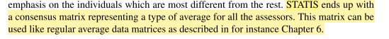
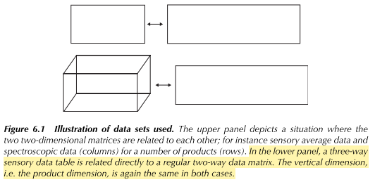
QUINDI FAI REPMAT PER $w_{ik}$ IN QUESTO CASO

(…….)
NO TESTING OF SIGNIFICANCE

LO POSSO FARE CON PANELCHECK!

pre-processing of data for three way analysis:
Trying to improve three-way analysis by the use of pre-processing, there are two main aspects to take into account:
1. Correct for scale differences (SAME AS ABOVE)
2. Take the reliability of the assessors into account
The general structure of many three-way methods is the minimisation of the criterion (incorporating weights into account):

(See page 45 and Chapter 17).

SIMPLEST WAY TO INCORPORATE WEIGHTS IN THIS CRITERION


[naes1996] “Data pretreatment in TFWA models”
(5.2 Weighting)(Pag.320) In addition to standardizing the data by removing variation due to differences in attribute and assessor means, it is often sensible to standardize variation. This can be done by dividing each attribute by its standard deviation, and as with centering there are two options.
The standard deviation can be computed over the whole sample or for each assessor separately. As above, the two options have quite different effects on the results.
1. The first option considers each assessor to be using the same scale, so that if he/she uses a smaller part of the scale than the others, he will still after weighting have less influence on the TWFA solution than the rest. In other words, this type of weighting will only have an effect on the relative importance of the different attributes, with no reference to the difference in scale among the different assessors.
2. The second option on the other hand also has an effect on the relative importance of the different assessors by weighting them all equally. In this way, we can say that each assessor is transformed to the same scale.
The choice between the two weightings depends on what is believed about the assessors' performance: if it is thought that an assessor will use a large part of the scale if he/she is confident about there being a large difference between the samples, and that a small difference means he/she perceived very little difference, then the weighting should be across all assessors. If on the other hand it is believed that each assessor perceives differences in the same way, and simply chooses to use the scale differently, then the standardization should be done within assessors.
This gives rise to another possible scaling, in which each assessor is given weight proportional to his ability to detect differences among the objects. One way to do this, if there is replication within assessors, is to 3. give each assessor a weight proportional to his average F-value for the different attributes. This could for instance be combined with centering the different attn'butes within each assessor. Another poss~ility is to give each assessor and attn~oute combination a weight proportional to its particular F-value.

Handling replicates (tracks in
(…) IN “HANDLING OF REPLICATES” (Section 7 pag.323)
from [zach2019]
“Replication: A partial or complete replication of an experiment (labelled Replicate) may be of interest to you, if you wish to study how stable your results are either for the experiment as a whole or per assessor;”
from [Science2010]
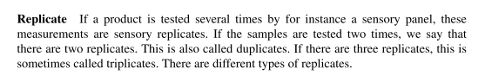
REPETITION IS IF IT IS REPEATED BY THE WHOLE PANEL!!!
[naes1996] Pag.323
(…)From the point of fitting the model, taking means over replicates would usually be the most sensible choice. The only point in doing otherwise, apart from diagnostic reasons given above) would be if there was some useful information in them, e.g. if they represented different orders of tasting and so there was a systematic reason why the replicates should be different. If the only reason for differences between the replicates is noise, then it makes little sense to model this noise and replicates should be averaged over.

Validation stuff
Cerca per validation of the models!
For example, even PCA can be used for validation (and outlier detection)! (See [Science2010] 14.9)
validation (and outlier detection) with multiple regression, pcr, pls [Science 2010] chapt.15.9
One can test hypotheses about the parameters!! (see [Science2010] chap.11.7 && codici matlab ML)

Chapter 8.7 from [Science2010]
As soon as the factor effects are computed, the model should be validated. As also discussed in Chapter 15, for validating a model properly it is simply not enough to just compare the fitted model values with the raw data since the data used for fitting the model will always fit better than new data. This may lead to overoptimistic results regarding the usefulness of the model. The best is of course to compare a model with real behaviour of consumers, but this is often very difficult in practice and one usually needs to rely on data based on consumer ratings CIO’ CHE NON POSSIAMO FARE NOI…
•Prediction testing
- For comparing model values with measured values in a new data set, it may be useful to compute the correlation between the measured and predicted values and to compare this with the correlation coefficient obtained in the estimation
- compute the root mean square error of prediction (RMSEP) ($→$ SECTION 15.9)
- may also be useful to look at the residuals plotted as a function of the predicted value or as a function of one or several of the experimental factors in order to reveal possible systematic tendencies.
If no new data are available, it is possible to do much of the same as described above by using so-called
•Cross-validation (see Chapter 15) i.e. by splitting the data in two or several subsets and then test on samples that have not been part of the estimation
CONS:
- The drawback with this method is that it only validates the model shape since the estimates are different in each segment.
- Another drawback is that the number of samples in each segment is smaller than the full set and the validation results are not totally representative for the data set used for fitting.
SO
- Also in this case plotting the residuals may be an important additional tool for detecting possible discrepancies between model and data (see Chapter 15 for how to do this).
The comments given here hold regardless of whether one uses PCA on the average sensory profiles or on the unfolded matrix of individual sensory profiles (see Tucker-1 THEN). For sensory analysis:
- mean centering is always done for each attribute
- eliminate the variables that do not significantly distinguish between the products before standardization. This can always be done by the use of two-way ANOVA as is discussed in Chapters 5 and 13 if two or more replicates are used
if some of the variables have a small variance and this is due to the fact that there is no or very little significant information in them, automatic standardising will ‘blow up’ the noise in these variables and make the noise equally important as the more informative variables in the rest of the sensory profile. Such variables may have an unfortunate effect on the PCA solution. Therefore, it is a sensible practice to eliminate the variables that do not significantly distinguish between the products before standardisation.
- standardization is often done (usually only a moderate effect on the conclusion drawn)
It is important to emphasise that the variables after standardisation have a slightly different interpretation than before standardisation. Performing a standardisation implicitly assumes that the original length of the scale used for the different attributes have no direct interpretation and meaning. In other words, differences in range for the different attributes are considered as uninteresting and only due to the calibration of the panel. NO!!

Validation
In regression analysis (Chapter 15) empirical validation of models is very important for the purpose of getting information about how good the model is for prediction. In the following we will discuss briefly how these methods can be used for determining how many PCA components that can be looked at safely. In most cases one will use only 2 or 3 components, but even for this small number of components one is interested in how reliable the components are.
The most fortunate situation to be in from an empirical validation point of view is when the samples are selected at random from a population of samples and the number of samples is reasonably large NOT OURS!! In this case one can use
- cross-validation (CV)
- prediction testing (see Chapter 15) to get an idea of the importance or significance of the different components extracted.
Both of these methods are based on the idea of modelling some of the samples in the data set (training data) and testing out on some others (test data). Prediction testing is the best and simplest, but requires that a number of objects (for instance 30 %) are set aside for testing only. Cross-validation, based on leaving one or a few samples out in sequence, is more appropriate when the number of samples is small. For both methods the testing is done by calculating the residuals after fitting of the test vectors y to the loadings
(…)
In situations with a small set of samples or samples based on an experimental design, the prediction testing and CV are more problematic to use. The reason for this is that each sample is unique and it is not necessarily possible that each sample fits into the model determined by the rest of the samples. In such cases other methods may be more useful for obtaining information about validity of the components for interpretation purposes.
- One possibility is to look at the explained variance for different number of components when fitting the model. If this explained variance curve goes up in a steep way before coming to a point where it clearly flattens out, this point is an indication of where one should stop interpreting components.
- Another important ‘tool’ is interpretation itself. If the interpretation makes sense in terms of previous knowledge or the design behind the study, this is a good argument for validity of the results. In some cases, one may also have prior knowledge regarding for instance correlation structure among variables and/or similarity between samples, which can be useful.
- An alternative type of CV for PCA was proposed in Wold (1978) where observations were removed according to a certain pattern in the data table. One should, however, always remember that in practice it is difficult to interpret more than 2–3 components.

[zach2019] ABOUT MULTIVARIATE STATISTICS IN SOUND

The best assessors are those with a low p-value and a corresponding low MSE value, meaning that they discriminate between the samples and at the same time are able to reproduce their own scores reliably. Note, however that the p-value can be low even though the MSE value is relatively high if the assessor uses a large portion of the scale. In p*MSE plots one can plot p-values and MSE values of all possible assessor-attribute combinations and highlight the assessor or the attribute one is interested in. Again, each point in the p*MSE plot represents an assessor-attribute combination

